**Unit 5 Study Guide**

**Maps/Cartoons/Graphs:**

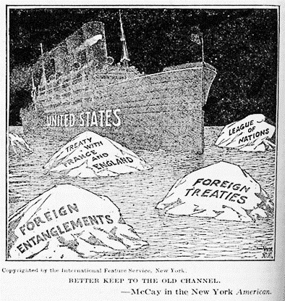 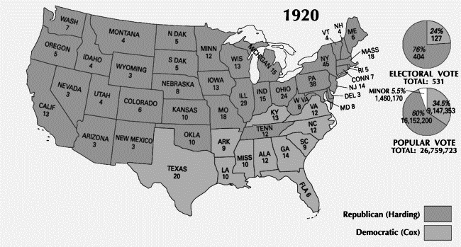

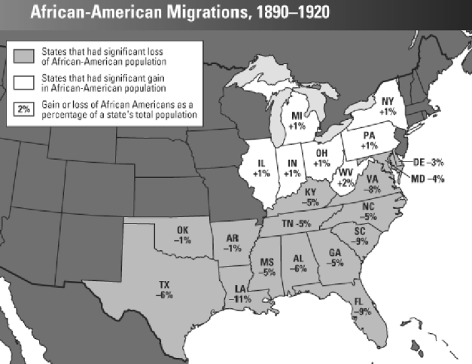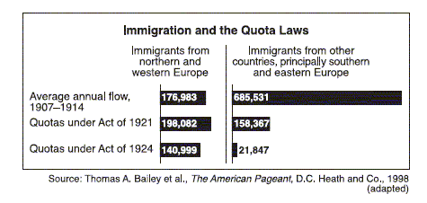

 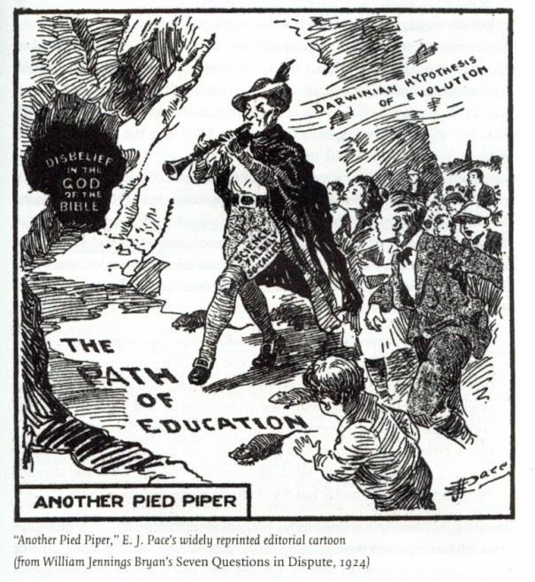

**Excerpts/Quotes:**

“The blaze of revolution was sweeping over every American institution of law and order…..eating its way into the homes of the American workman, its sharp tongues of revolutionary heat….licking the altars of the churches, leaping into the belfry of the school bell, crawling into the sacred corners of American homes,….burning up the foundations of society.”

-A. Mitchell Palmer

“In all my life I have never stole, never killed, never spilled blood…We were tried during a time…when there was hysteria of resentment and hate against the people of our principles, against the foreigner…I am suffering because I am a radical and indeed I am a radical; I have suffered because I was an Italian and indeed I am an Italian…If you could execute me two times, and I could be reborn two other times, I would live again to do what I have done already”

-quoted in *The National Experience*

“America’s present need is not heroics, but healing; not nostrums, but normalcy; not revolution, but restoration; not agitation, but adjustment; not surgery, but serenity; not the dramatic, but the dispassionate; not experiment, but equipoise; not submergence in internationality, but sustainment in triumphant nationality.”

-Warren G. Harding

People living in the cities and areas of industry benefited most from the increased prosperity although there were arguments to the contrary. Those living in rural areas did not benefit to the same extent, and this was made worse by widespread drought. This encouraged population movement from rural areas to cities, a trend which has continued down to the present day. The Department of Agriculture calculated that the net migration in favor of the cities was over one million people.

**Be able to identify the following from the 1920s:**

1. Social Change
2. Economic Change
3. Political Change