“In these days men have learned the art of sinning expertly and genteelly, so as not to shock the eyes and senses of respectable society. Human property is high in the market; and is, therefore, well fed, well cleaned, tended, and looked after, that it may come to sale sleek, and strong, and shining.” - Harriet Beecher Stowe, *Uncle Tom’s Cabin*

“If the people of Kansas want a slaveholding state, let them have it, and if they want a free state they have a right to it, and it is not for the people of Illinois, or Missouri, or New York, or Kentucky, to complain, whatever the decision of Kansas may be.” - Stephen A. Douglass

“No man, however benevolent, liberal, and wise, can use a large fortune so that it will do half as much good in the world as it would if it were divided into moderate sums and in the hands of workmen who had earned it by industry and frugality.”

-*Rutherford B. Hayes*

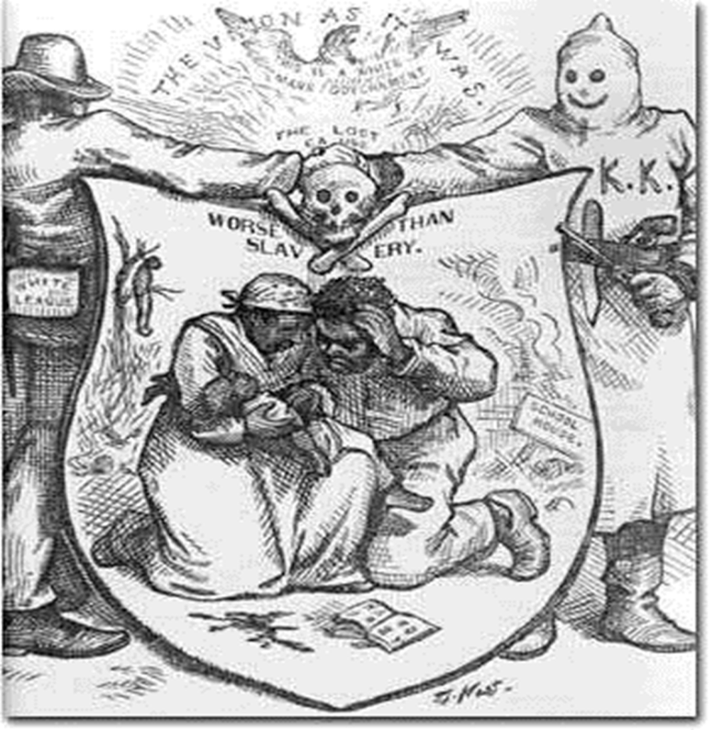

**“The Modern Colossus of (Rail) Roads”**

Joseph Keppler drew this cartoon in 1879, featuring the railroad “giants” William Vanderbilt (top), Jay Gould (bottom right), and Cyrus W. Fields (bottom left). The three magnates formed a railroad trusts out of their Union Pacific, New York Central, and Lake Shore and Independent lines.

[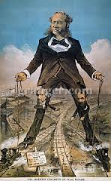](http://www.google.com/imgres?hl=en&tbo=d&biw=1920&bih=932&tbm=isch&tbnid=l6T-Xx6Qy6e9zM:&imgrefurl=http://www.flickr.com/photos/thegrangercollection/5495141768/&docid=DCcrtwoHkl6-yM&imgurl=http://farm6.staticflickr.com/5174/5495141768_a4811f5611.jpg&w=185&h=300&ei=yzGZULjvD5GDqgGHl4GwAQ&zoom=1&iact=hc&vpx=1717&vpy=393&dur=1347&hovh=240&hovw=148&tx=93&ty=107&sig=106391544088926201641&page=1&tbnh=148&tbnw=91&start=0&ndsp=57&ved=1t:429,r:36,s:20,i:242)

“Now then Jim…No jockeying you know” “Let ‘em Rip Commodore….! But don’t stop

to water or you’ll be beat”

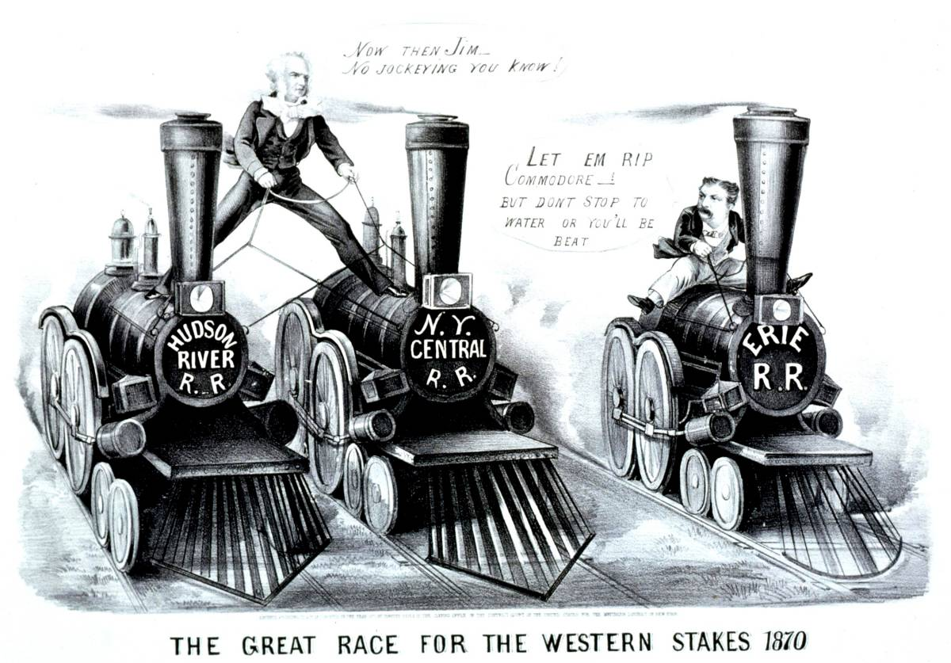

[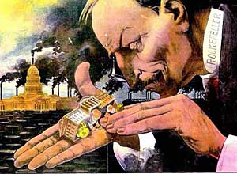](http://history.osu.edu/projects/uscartoons/verdict/ht/22Jan1900.htm)





The Gettysburg Address

By: Abraham Lincoln

Four score and seven years ago our fathers brought forth on this continent a new nation, conceived in liberty, and dedicated to the **proposition** that all men are created equal.

Now we are engaged in a great civil war, testing whether that nation, or any nation, so conceived and so dedicated, can long endure. We are met on a great battle-field of that war. We have come to **dedicate** a portion of that field, as a final resting place for those who here gave their lives that that nation might live. It is altogether fitting and proper that we should do this.

But, in a larger sense, we cannot dedicate, we cannot **consecrate**, we cannot hallow this ground. The brave men, living and dead, who struggled here, have consecrated it, far above our poor power to add or detract. The world will little note, nor long remember what we say here, but it can never forget what they did here. It is for us the living, rather, to be dedicated here to the unfinished work which they who fought here have thus far so nobly advanced. It is rather for us to be here dedicated to the great task remaining before us—that from these honored dead we take increased devotion to that cause for which they gave the last full measure of **devotion**—that we here highly resolve that these dead shall not have died in vain—that this nation, under God, shall have a new birth of freedom—and that government of the people, by the people, for the people, shall not perish from the earth.