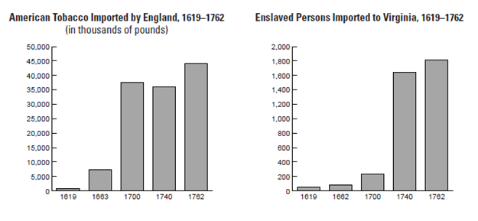

**A DISASTROUS START**

Unlike Spanish colonies, which were funded by Spanish rulers, the English colonies were originally funded by joint-stock companies. Stock companies allowed several investors to pool their wealth in support of a colony that would, they hoped, yield a profit. Investors in the Jamestown colony demanded a quick return on their investment, and the colonists hoped to find gold to satisfy them. Consequently, they neglected farming and soon suffered the consequences. Disease from contaminated river water struck them first, followed soon by hunger. After several months, one settler described the terrifying predicament: “Thus we lived for the space of five months in this miserable distress, . . . our men night and day groaning in every corner of the fort, most pitiful to hear.”

Smith held the colony together by forcing the colonists to farm and by securing food and support from the native Powhatan peoples. Then Smith was injured and returned to England. Without Smith’s leadership, the colony eventually deteriorated to the point of famine. The settlement was saved, however, by the arrival of new colonists and by the development of a highly profitable crop, tobacco. -- *The American’s Textbook*

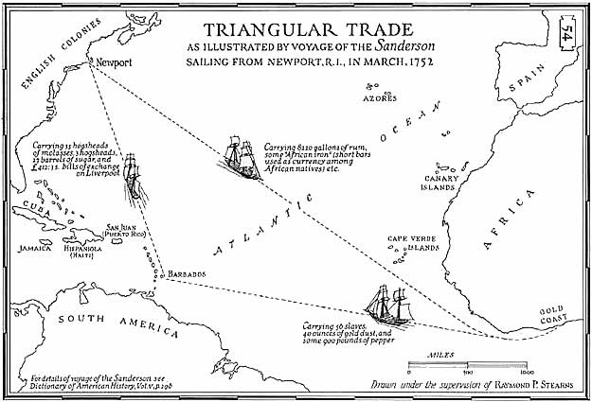

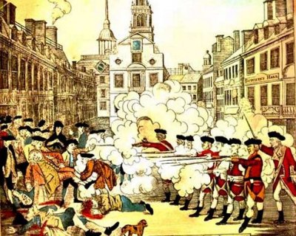

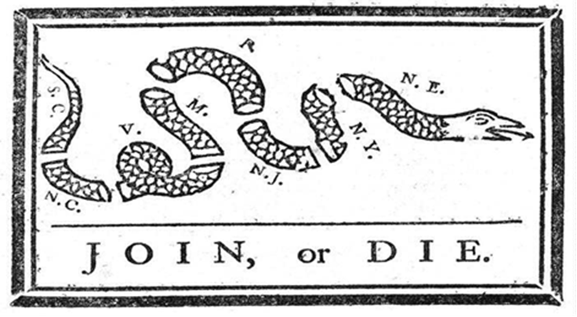

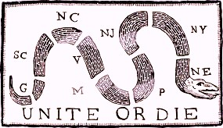

|  |  |
| --- | --- |
| Federalists | Democratic-Republican |
| Favored a strong  central government | Sought to limit the role  of the national  government |
| Supported Hamilton’s economic plans  Enthusiastically (Federal Bank) | Opposed Hamilton’s  Plans for a Federal Bank |
| New England states (Rich and powerful merchants) | Southern States and Western Territories/States (Poorer farmers) |
| The Constitution is a literal document in which there is NO interpretation. | The Constitution is a framework in which we run the country, but not to be taken word for word. |

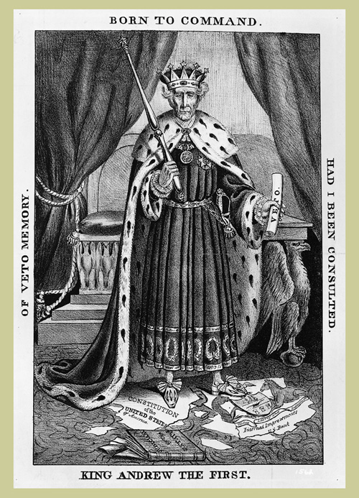

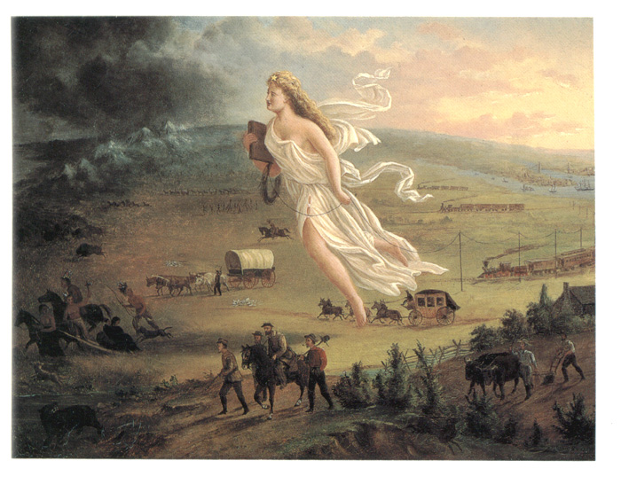

“With all [our] blessings, what more is necessary to make us a happy and a prosperous people? Still one thing more, fellow citizens—a wise and frugal Government, which shall restrain men from injuring one another, shall leave them otherwise free to regulate their own pursuits of industry and improvement, and shall not take from the mouth of labor the bread that it has earned. This is the sum of good government.”

--*from* Thomas Jefferson’s First Inaugural Address, 1801

