**U.S. Entry Into “The Great War”**

***Crisis #1:*** *Sinking of the Lusitania*



The notice below accompanied the advertisement on the left.

   

***Crisis #2:*** *Unlimited Submarine Warfare*

Below is the text of the diplomatic note sent by the German government – via their Ambassador to the U.S., Count Johann von Bernstorff – to the U.S. Secretary of State, Robert Lansing.

In the note, Bernstorff announced a re-opened German policy of unrestricted submarine warfare (initially introduced and then rapidly abandoned in 1916 owing to U.S. protests), to take effect the day following the date of the note (February 1, 1917). The German Chancellor Theobald von Bethmann-Hollweg spoke before the Reichstag on the same day to explain the reasons for the policy.

In effect, the policy set in place a blockade of Britain and her European allies, to be applied to belligerent and neutral shipping alike. The German government argued that such a policy was implemented only as an aggressive form of defense.

Reaction to the policy was rapid; the Allied powers inevitably decried its aggression, as did the U.S. government, which broke off diplomatic relations on February 3, 1917. On the same day, President Woodrow Wilson appeared before Congress to announce his reasons, receiving virtually unanimous support in doing so.

**Germany’s declaration of unlimited submarine warfare effective February 1, 1917, message from German Ambassador Count Johann von Bernstoff to the U.S. Secretary of State, Robert Lansing**:

*A new situation has thus been created which forces Germany to new decisions. Since two years and a half England is using her naval power for a criminal attempt to force Germany into submission by starvation. In brutal contempt of international law, the group of powers led by England not only curtail the legitimate trade of their opponents, but they also, by ruthless pressure, compel neutral countries either to altogether forego every trade not agreeable to the Entente Powers [England and its allies]…*

*Since the attempts to come to an understanding with the Entente Powers have been answered… with the announcement of an intensified continuation of the war, the Imperial Government [Germany]--in order to serve the welfare of mankind in a higher sense and not to wrong its own people--is now compelled to continue the fight for existence… with the full employment of all the weapons which are at its disposal.*

*Sincerely trusting that the people and the Government of the United States will understand the motives for this decision and its necessity, the Imperial Government hopes that the United States may view the new situation from the lofty heights of impartiality, and assist, on their part, to prevent further misery and unavoidable sacrifice of human life…*

*From February 1, 1917, sea traffic will be stopped with every available weapon and without further notice in… blockade zones around Great Britain, France, Italy and in the Eastern Mediterranean.*

***Crisis #3:*** *The Zimmerman Telegram*

 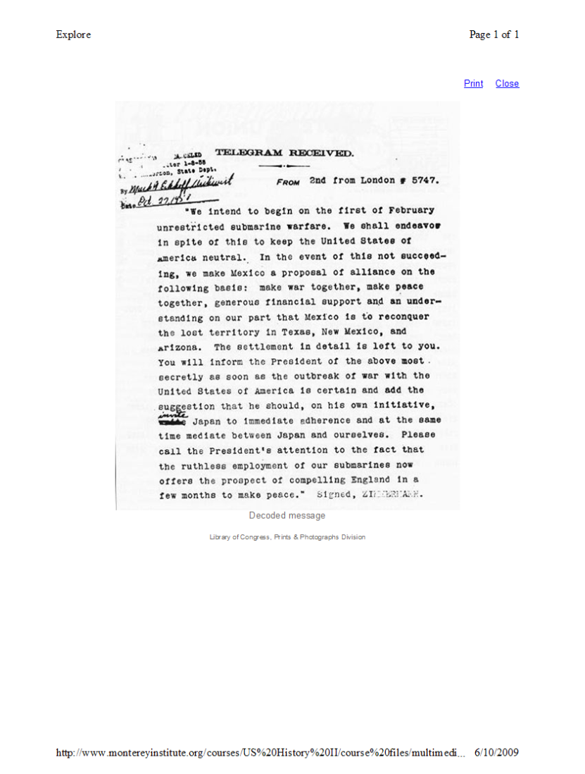

**Analysis Questions**

***Crisis #1:*** *The Lusitania -*

1. Why were travelers being warned that if they rode on the *Lusitania* they would have to do so at their own risk?
2. According to the notice where was the “zone of war”?
3. What effect might the sinking of the *Lusitania* have had on the United States at the time?
4. If you were president of the United States, would you want to enter the war after Americans lost their lives in the sinking of the ship? Why or why not?

***Crisis #2:*** *Unlimited Submarine Warfare -*

1. What event do you think caused the Germans to abandon the first unrestricted submarine warfare declaration?
2. What reasons did the Germans give for re-instituting the warfare policy?
3. The Germans hoped that the U.S. would understand, however, how did the U.S. respond?

***Crisis #3:*** *The Zimmerman Telegram -*

1. What does the telegram reveal about Germany’s plans regarding submarine warfare?
2. What offer do the Germans make to Mexico if they will go to war with the U.S.?
3. What role does Zimmerman want Mexico to play in the war? Do you think Mexico would have agreed to this?
4. Why do you think the Zimmerman telegram provoked the U.S. to enter the war?
5. Would the United States have remained neutral if the Zimmermann telegram had not been revealed? Explain.