**Triangular Trade Activity**

***Directions:*** On the map below, draw the triangular trade routes and list what types of items were moving on each part of the trade routes (raw materials/slaves/manufactured goods). Then, using knowledge of the Triangular Trade and knowledge, chart the origin of commodities listed (some may originate from places OTHER THAN the points on the Triangular Trade, but are still elements of the Columbian Exchange), then indicate their destination.

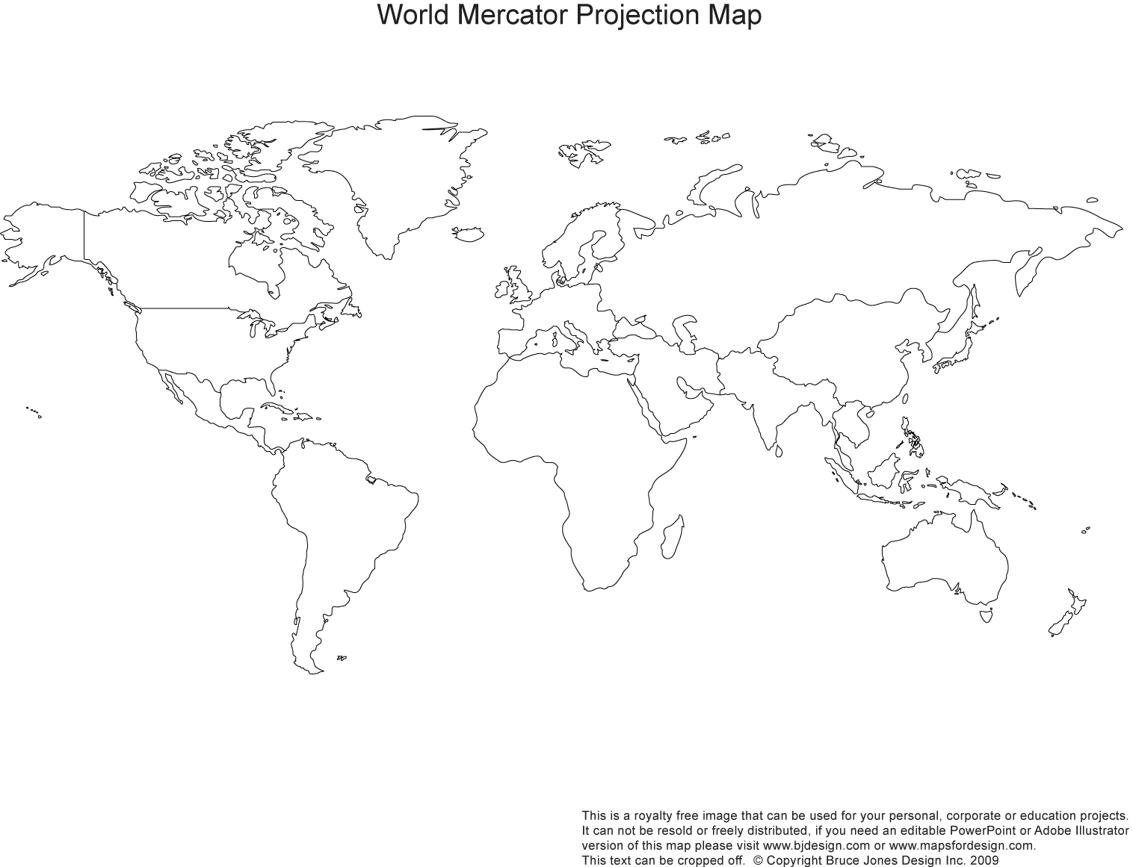

|  |  |  |
| --- | --- | --- |
| **Commodity** | **Origin (Area from)** | **Destination (Going to)** |
| Gold/Silver |  |  |
| Sugar |  |  |
| Slaves |  |  |
| Tobacco |  |  |
| Cotton |  |  |
| Guns |  |  |
| Rum |  |  |
| Horses |  |  |
| Textiles |  |  |

***Think & Answer:*** You are a cotton grower with a large plantation near the port of Charleston. Because of British mercantilist policies, price for cotton is fixed according to British law. The cotton is sent to England where the British create cotton textiles. They then sell it (for gold) to America, France, and South America for a huge profit. How does this affect you as a colonial grower? How is this beneficial for England and negative for France and Spain?

**The Middle Passage**

**“Captured!”**

**Excerpt from:**

**Olaudah Equiano, The Interesting Narrative**

“I was born in the year 1745, in a charming fruitful vale, named Essaka [The Benin Kingdom of Africa]…My father was one of [the] elders or chiefs…As I was the youngest of the sons, I became, of course, the greatest favourite with my mother, and was always with her; and she used to take particular pains to form my mind…In this way I grew up till I was turned the age of eleven, when an end was put to my happiness in the following manner…

One day, when all of our people were gone out to their works as usual, and only I and my dear sister were left to mind the house, two men and a woman got over our walls, and in a moment seized us both; and without giving us time to cry out, or make resistance, they stopped our mouths, tied our hands, and ran off with us into the nearest wood: and continued to carry us far as they could, till night came on, when we reached a small house, where the robbers halted for refreshment, and spent the night. We were then unbound, but were unable to take any food…

The next morning we left the house, and continued traveling all the day…I had now some hopes of being delivered; for we had advanced but a little way before I discovered some people at a distance, on which I began to cry our for their assistance; but my cries had not other effect than to make them tie me faster, and stop my mouth, and then they put me into a large sack….”

Source: Equiano, Olaudah. The Interesting Narrative and Other Writings. Originally Published in 1789. New York: Penguin Books, 1995.

**Plan of British Slave Ship “Brookes”, 1789**



Source: Broadside collection, Rare Book and Special Collections Division, Library of Congress (Portfolio 282-43 [Library of Congress, Prints and Photographs Division, LC-USZ62-44000]; also, Special Collections Department, University of Virginia Library and Library Company of Philadelphia.

**“Sold!”**

**Excerpt from:**

**Olaudah Equiano, The Interesting Narrative**

“…We were conducted immediately to the merchant’s yard, where we were all pent up together like so many sheep in a fold, without regard to sex or age…

We were not many days in the merchant’s custody before we were sold after their usual manner, which is this: -On a signal given, (as the beat of a drum), the buyers rush at once in to the yard where the slaves are confined, and make choice of that parcel they like best. The noise and clamor with which this is attended, and the eagerness visible in the countenances of the buyers, serve not a little to increase the apprehensions of the terrified Africans…In this manner, without scruple, are relations land friends separated, most of them never to see each other again…”

Source: Equiano, Olaudah. The Interesting Narrative and Other Writings. Originally Published in 1789. New York: Penguin Books, 1995.

***Document Analysis:***

1. Using your knowledge of triangular trade, why is another term for the slave trade “the middle passage”?
2. Describe the three parts of the “middle passage” using the documents given to you to analyze.
   * Enslavement in Africa:
   * Voyage across the Atlantic:
   * Arrival in the Americas: