Name:
Period:

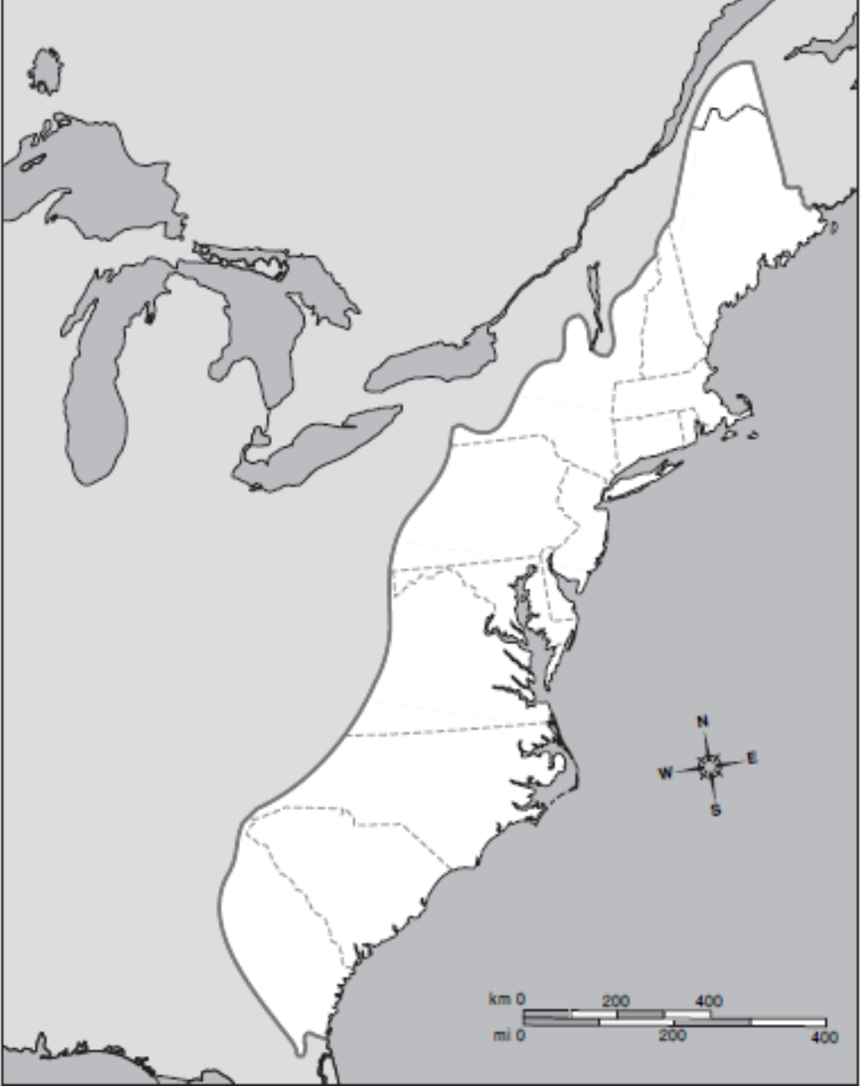
13 Colonies/Regionalism Map
Directions: Using the map on page 29 in your book label and color the following on the map:
- 13 British colonies (years they were founded), New France, New Spain
- Delaware River, Potomac River, Hudson River, Appalachian Mountains, Atlantic Ocean,
- Boston, Philadelphia, New York City, Baltimore, and Charleston.
- Decide on the 3 most common economic activities for the northern and southern colonies and create a key on the map to label them accurately.
- What difference do you notice between the northern and the southern colonies?

Key

