**U.S. History – Midterm Study Guide**

1. Be able to match characteristics of a Spanish colony or English colony:

|  |  |
| --- | --- |
| **Spanish Colony** | **English Colony** |
|  |  |

1. What is triangular trade?
2. **Documents**:

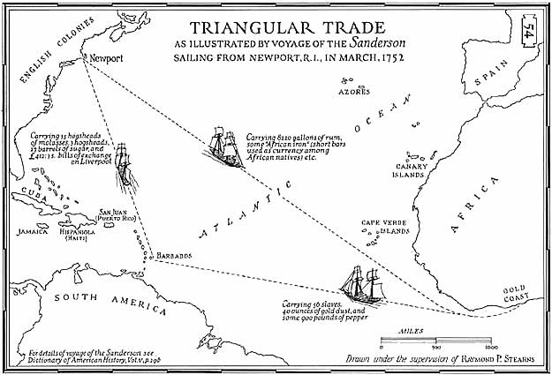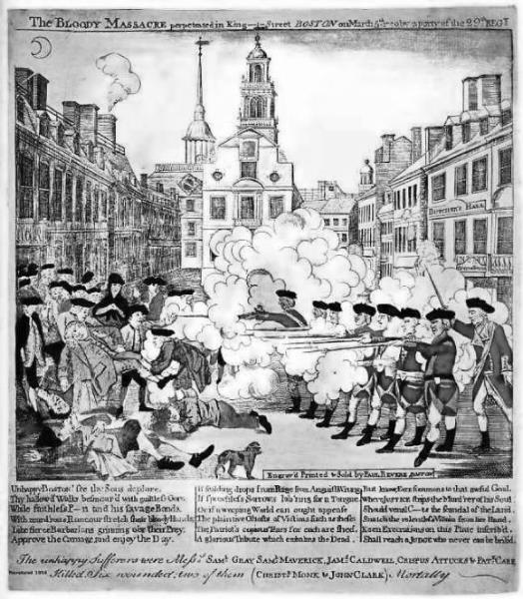

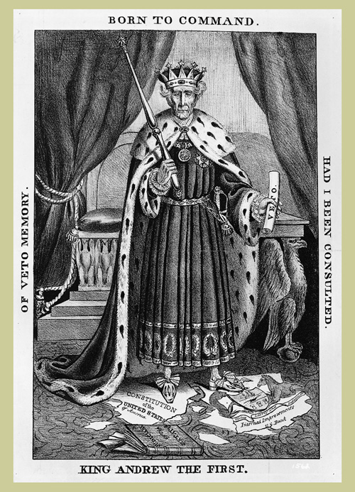 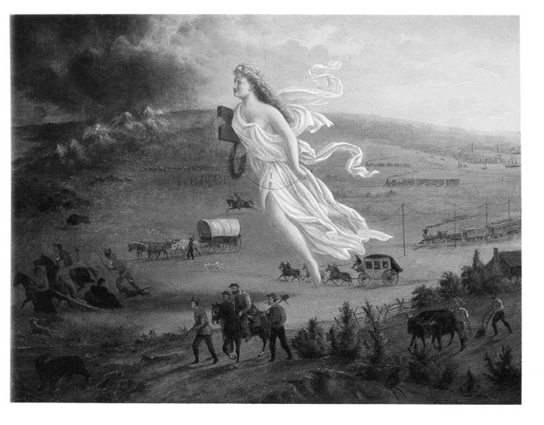

1. When were the Lincoln-Douglas Debates held?
2. When was Lincoln elected President?
3. When did South Carolina secede?
4. **Documents**:

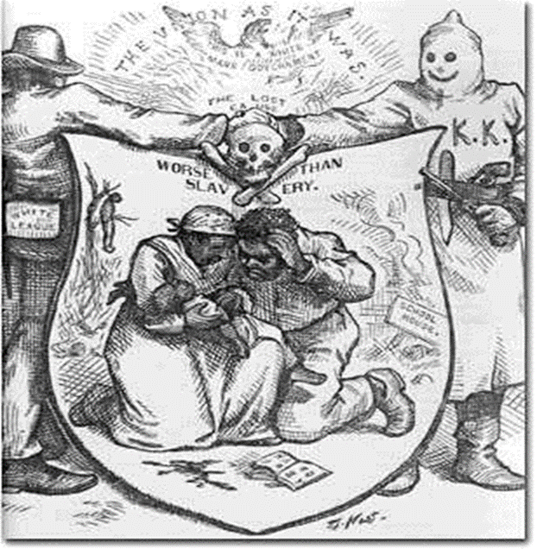 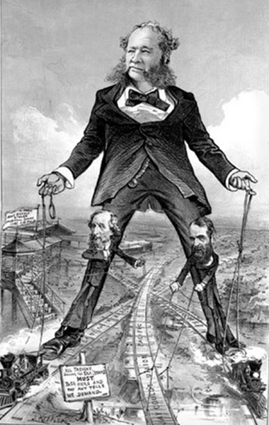

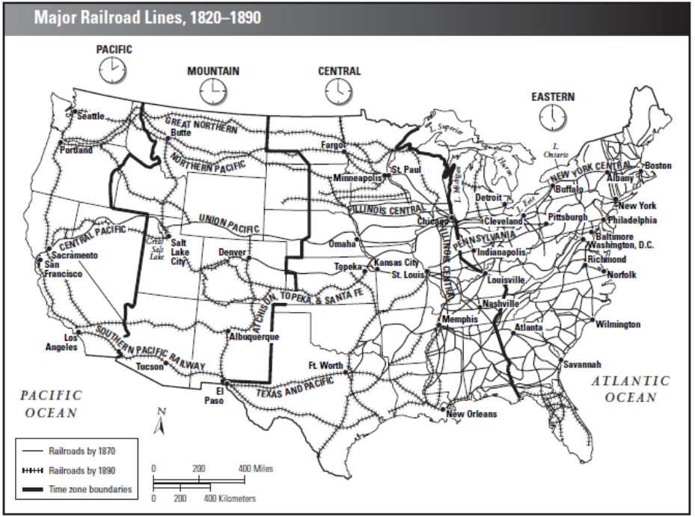

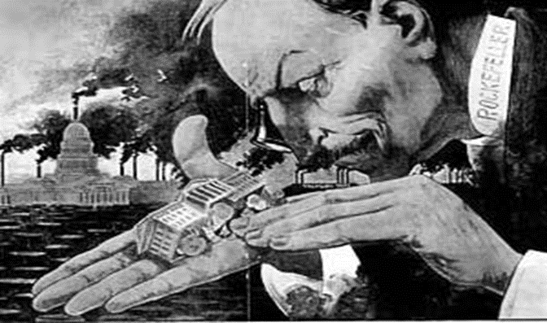

1. **Excerpt:** The railroads, with thousands of miles of track, became the biggest customers for steel, but inventors soon found additional uses for it. Joseph Glidden’s barbed wire and McCormick’s and Deere’s farm machines helped transform the plains into the food producer of the nation.

Steel changed the face of the nation as well, as it made innovative construction possible. One of the most remarkable structures was the Brooklyn Bridge. Completed in 1883, it spanned 1,595 feet of the East River in New York City. Its steel cables were supported by towers higher than any man-made and weight-bearing structure except the pyramids of Egypt. Like those ancient marvels, the completed bridge was called a wonder of the world.

Around this time, setting the stage for a new era of expansion upward as well as outward, William Le Baron Jenney designed the first skyscraper with a steel frame—the Home Insurance Building in Chicago. Before Jenney had his pioneering idea, the weight of large buildings was supported entirely by their walls or by iron frames, which limited the buildings’ height. With a steel frame to support the weight, however, architects could build as high as they wanted. As structures soared into the air, not even the sky seemed to limit what Americans could achieve.

1. Describe the following goals of Progressivism:
   1. Protecting Social Welfare:
   2. Promoting Moral Reform:
   3. Creating Economic Reform:
   4. Fostering Efficiency:
2. **Documents**:

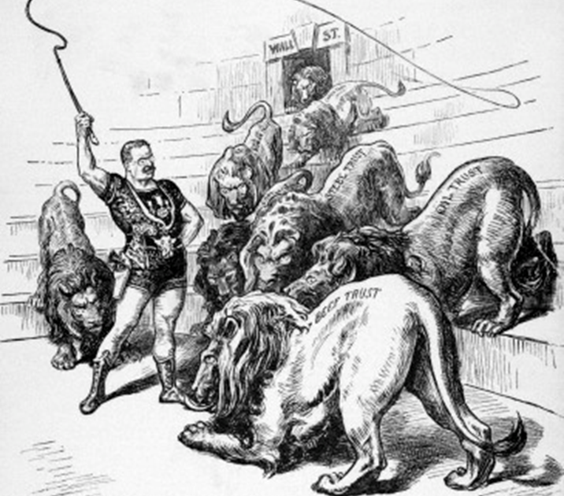

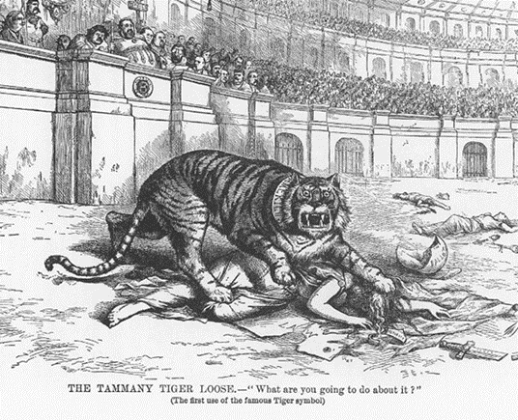

1. **Excerpt**: “There was another interesting set of statistics that a person might have gathered in Packingtown—those of the various afflictions of the workers. When Jurgis had first inspected the packing-plants with Szedvilas, he had marveled while he listened to the tale of all the things that were made out of the carcasses of animals, and of all the lesser industries that were maintained there; now he found that each one of these lesser industries was a separate little inferno, in its way as horrible as the killing-beds, the source and fountain of them all. The workers in each of them had their own peculiar diseases. And the wandering visitor might be skeptical about all the swindles, but he could not be skeptical about these, for the worker bore the evidence of them about on his own person—generally he had only to hold out his hand.”
2. **Excerpt:** “Fate has written our policy for us; the trade of the world must and shall be ours…We will establish trading posts throughout the world as distributing points for American products…Great colonies governing themselves, flying our flag and trading with us, will grow about our posts of trade”
3. **Documents:**

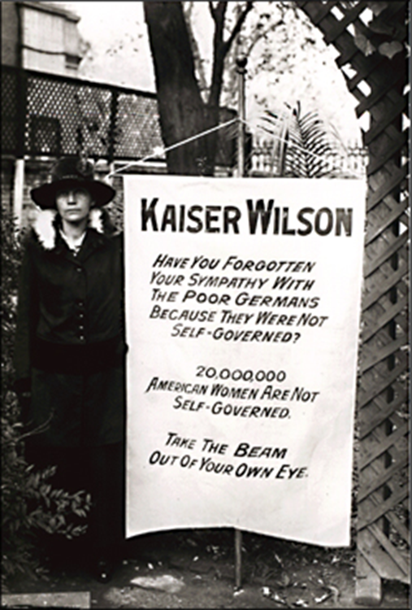 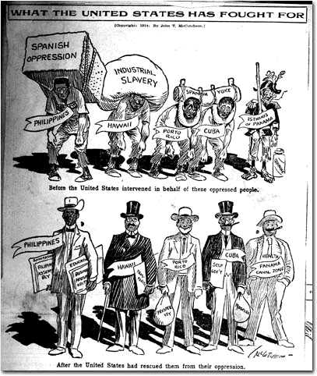

1. Describe the following cause/goal of U.S. Imperialism:
   1. Military strength:
   2. Thirst for New Markets:
   3. Belief in Cultural Superiority of white, English speakers:
2. **Documents:**

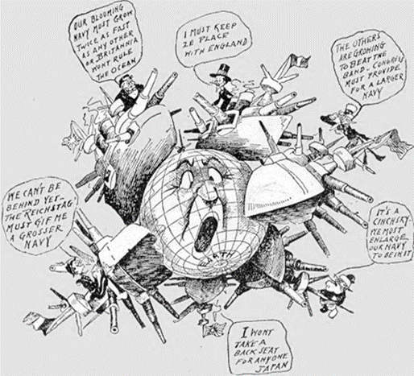 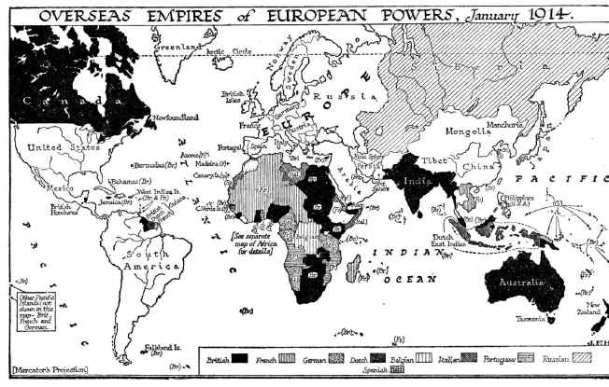

1. **Primary Source:**

*The Zimmerman Note*

Berlin, January 19, 1917

On the first of February we intend to begin submarine warfare unrestricted. In spite of this it is our intention to keep neutral the United States of America.

If this attempt is not successful we propose an alliance on the following basis with Mexico: That we shall make war together and together make peace. We shall give general financial support, and it is understood that Mexico is to reconquer the lost territory in New Mexico, Texas, and Arizona. The details are left for your settlement.

You are instructed to inform the President of Mexico of the above in the greatest confidence as soon as it is certain there will be an outbreak of war with the United States, and we suggest that the President of Mexico on his own initiative should communicate with Japan suggesting adherence at once to this plan; at the same time offer to mediate between Germany and Japan.

Please call to the attention of the President of Mexico that the employment of ruthless submarine warfare now promises to compel England to make peace in a few months.

Zimmerman

1. **Graph:**
2. **Maps:**

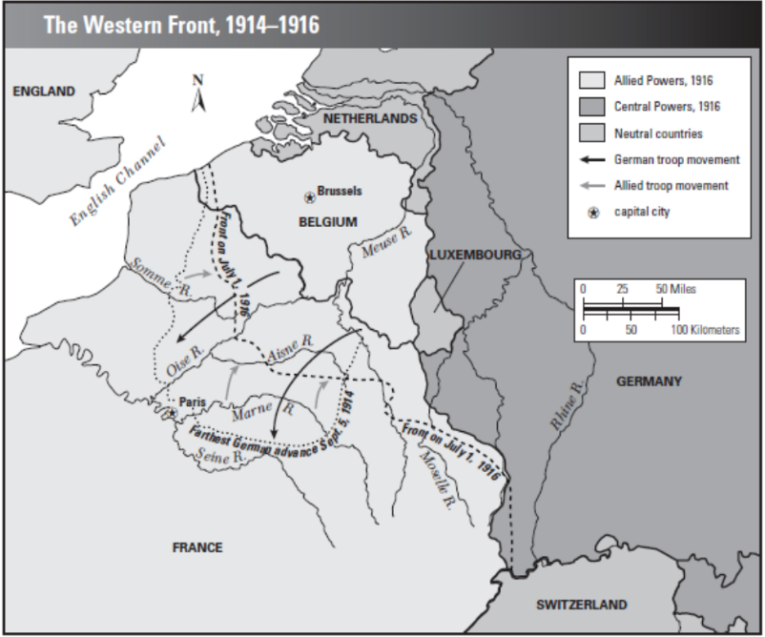



1. **Cartoon:**

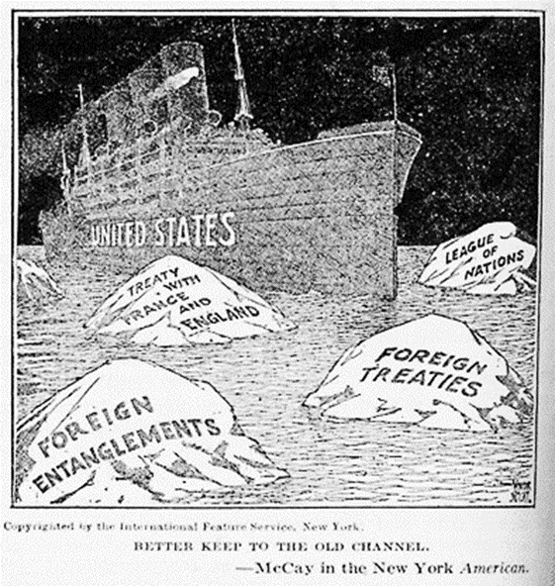

1. **Quotes:**
   1. “The blaze of revolution was sweeping over every American institution of law and order…..eating its way into the homes of the American workman, its sharp tongues of revolutionary heat….licking the altars of the churches, leaping into the belfry of the school bell, crawling into the sacred corners of American homes,….burning up the foundations of society.”
   2. “America’s present need is not heroics, but healing; not nostrums, but normalcy; not revolution, but restoration; not agitation, but adjustment; not surgery, but serenity; not the dramatic, but the dispassionate; not experiment, but equipoise; not submergence in internationality, but sustainment in triumphant nationality.”
2. **Charts:**

