Name:________________________

Lebanon

Israel

Jordan

Saudi Arabia

Yemen

Oman

Syria

United Arab Emirates

Iraq

Iran

Afghanistan

Pakistan

Kuwait

Qatar

Label and color the countries of the Middle East and their capitals. Label the following water ways: Mediterranean Sea, Caspian Sea, Red Sea, Persian Gulf, Gulf of Aden, Arabian Sea, and Indian Ocean

[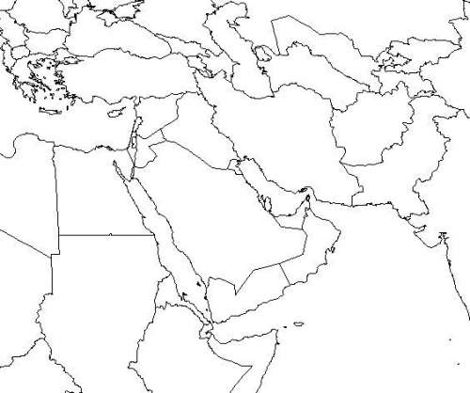](http://www.google.com/url?sa=i&rct=j&q=&esrc=s&source=imgres&cd=&cad=rja&uact=8&ved=0ahUKEwjPxdbBkb_XAhUo6oMKHfwaDHkQjRwIBw&url=http://questgarden.com/72/63/4/081105205100/task.htm&psig=AOvVaw2ql7aVtfOHuL8SSU1oFIPA&ust=1510785717699165)