Document A
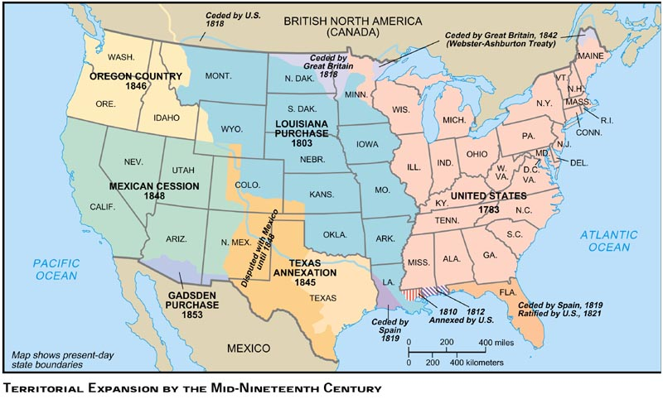

Document B
John Gast “American Progress” 1872.
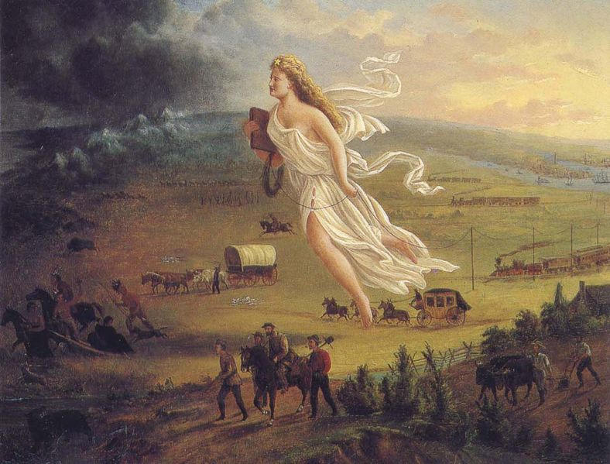

Document C
Source: James K. Polk, Inaugural Address, March 1845

Our title to the country of the Oregon is "clear and unquestionable," and already are our people preparing to perfect that title by occupying it with their wives and children. But eighty years ago our population was confined on the west by the ridge of the Alleghanies. Within that period—within the lifetime, I might say, of some of my hearers—our people, increasing to many millions, have filled the eastern valley of the Mississippi, adventurously ascended the Missouri to its headsprings, and are already engaged in establishing the blessings of self-government in valleys of which the rivers flow to the Pacific. The world beholds the peaceful triumphs of the industry of our emigrants. To us belongs the duty of protecting them adequately wherever they may be upon our soil. The jurisdiction of our laws and the benefits of our republican institutions should be extended over them in the distant regions which they have selected for their homes.

Document D
Source: John L. O’Sullivan on Manifest Destiny, 1839.

America is destined for better deeds. It is our unparalleled glory that we have no reminisces of battlefields, but in defense of humanity, of the oppressed of all nations, of the rights of conscience, the rights of personal enfranchisement…The expansive future is our arena, and for our history…We are the nation of human progress, and who will, what can, set limits to our onward march? Providence is with us, and no earthly power can. We point to the everlasting truth on the first page of our national declaration, and we proclaim and we proclaim to the millions of other lands, that “the gates of hell”—the powers of aristocracy and monarchy—“shall not prevail against it”…Yes we are the nation of progress, of individual freedom, of universal enfranchisement…freedom of conscience, freedom of person, freedom of trade…This is our highest destiny, and in nature’s eternal, inevitable decree of cause and effect we must accomplish it…our country is destined to be the great nation of futurity…

Document E
Texas has been absorbed into the Union as the inevitable fulfillment of the general law which is rolling our population westward....It was disintegrated from Mexico in the natural course of events, by a process perfectly legitimate on its own part, blameless on ours....
California will, probably next fall away from...Mexico...imbecile and distracted...The Anglo-Saxon foot is already on its borders....All this without agency of our government, without responsibility of our people--in the natural flow of events, the spontaneous working of principles....
Democratic Review 1845

Document F
Have not results in Mexico taught the invincibility of American arms?...The North Americans will spread out far beyond their present bounds. They will encroach again and again upon their neighbors. New territories will be planted, declare their independence, and be annexed. We have New Mexico and California! We will have Old Mexico and Cuba! The isthmus cannot arrest--nor even the Saint Lawrence!! Time has all of this in her womb. A hundred states will grow up where now exists but thirty.
DeBow's Commercial Review, 1848

