**U.S. History Final – Study Guide**

***Content Questions:***

1. Define the following terms:
   * Rugged Individualism
   * Cold War
   * Iron Curtain
   * Proxy War
   * Separate but equal
   * De facto segregation
   * Vietnamization
   * Counterculture
   * Cuban Missile Crisis
   * Operation Rolling Thunder
2. What were the causes of the Dust Bowl?
3. Define and give an example of a New Deal program for each of the following:
   * Relief:
   * Recovery:
   * Reform:
4. What strategy was used by the US to defeat the Japanese in the Pacific?
5. Why did women and minorities make economic and financial gains during WWII?
6. Explain the importance of D-Day.
7. What was the cause of the Berlin Airlift?
8. What was the outcome of the Korean War?
9. Why did the US see a communist Cuba as problematic?
10. Why did the Soviets build the Berlin Wall?
11. Where were sit-ins likely to occur?
12. What was the main goal of the freedom rides?
13. When did the following events happen:
    * Freedom Rides
    * March on Washington
    * Selma Campaign
    * Voting Rights Act
    * Civil Rights Act
14. What was the impact of *Feminine Mystique* on the women’s movement?
15. What did Mexican-American farmworkers organize a boycott of? Why?
16. What problems were faced by both Latinos and Native Americans in the 1960s and 1970s?
17. What was the main goal of the US in Vietnam?
18. Describe the tactics that the VietCong used against the US.
19. What was the main criticism of Johnson during the Vietnam War? (Think credibility)
20. Where did most anti-war protests occur?
21. Explain the outcomes of the Vietnam War here in America.
22. What president was never elected?
23. What president called the USSR the “evil empire”?
24. Who was the first president to resign?
25. Under what president did 9/11 occur?
26. Who was only the second president to be impeached?
27. Who was in office when the cold war officially ended?
28. Who referred to North Korea, Iran, and Iraq as the “axis of evil”?
29. What president had to deal with the Iranian hostage crisis?

***Political Cartoons/Posters/Maps/Charts/Graphs:***

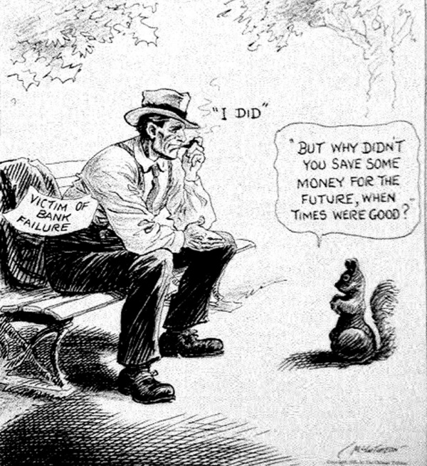 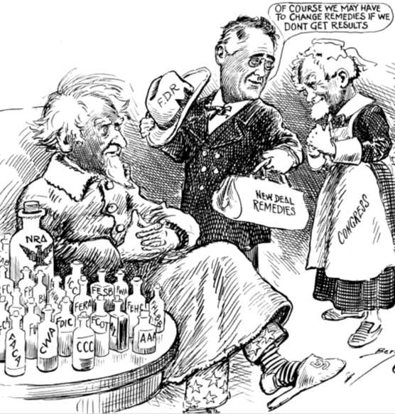

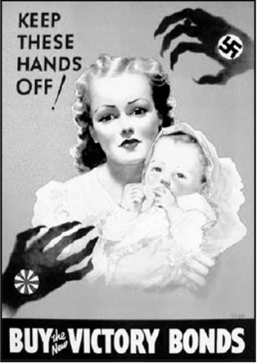 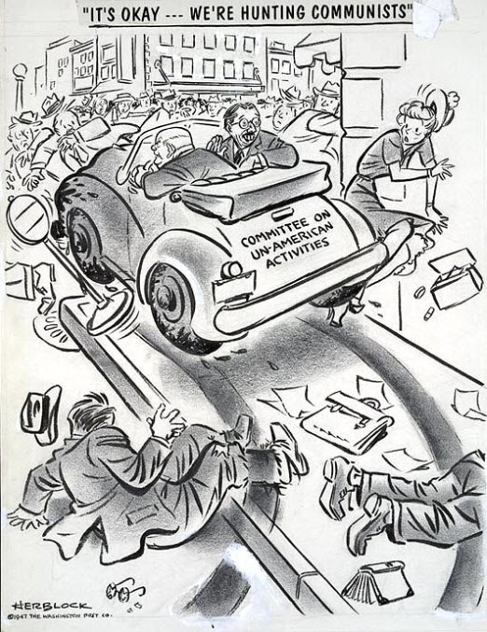

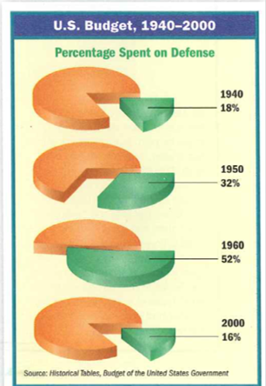 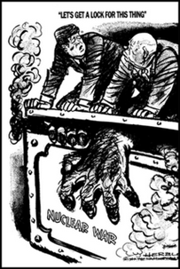

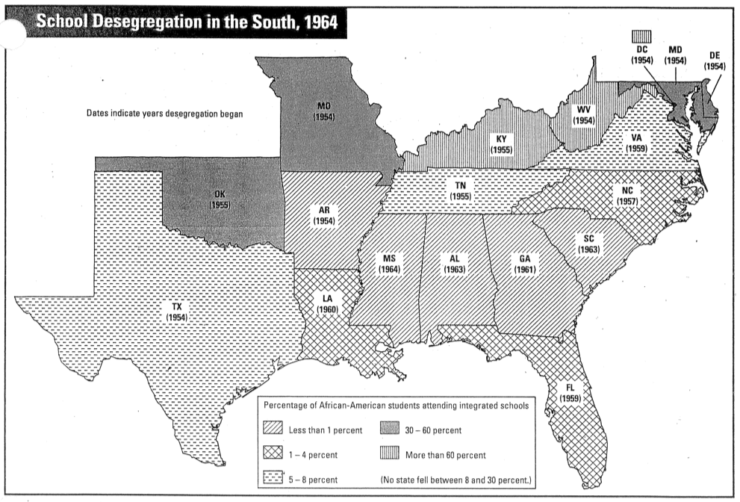

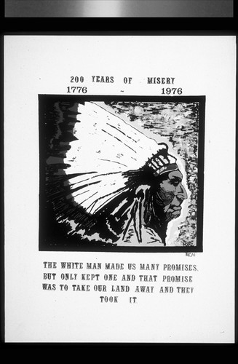 



 

***Passages:***

…In the future days, which we seek to make secure, we look forward to a world founded upon four essential human freedoms.

The first is freedom of speech and expression--everywhere in the world. The second is freedom of every person to worship God in his own way--everywhere in the world. The third is freedom from want--which, translated into world terms, means economic understandings which will secure to every nation a healthy peacetime life for its inhabitants-everywhere in the world. The fourth is freedom from fear--which, translated into world terms, means a world-wide reduction of armaments to such a point and in such a thorough fashion that no nation will be in a position to commit an act of physical aggression against any neighbor--anywhere in the world.

That is no vision of a distant millennium. It is a definite basis for a kind of world attainable in our own time and generation. That kind of world is the very **antithesis** of the so-called new order of tyranny which the dictators seek to create with the crash of a bomb.

**--President Franklin Roosevelt’s “Four Freedoms” Speech 1941**

“In 1945 I had ordered the A Bomb dropped on Japan at two places devoted almost exclusively to war production. We were at war. We were trying to end it in order to save the lives of our soldiers and sailors…We stopped the war and saved thousands of casualties on both sides.

In Korea we were fighting a police action with sixteen allied nations to support the World Organization which had set up the Republic of Korea. We had held the Chinese after defeating the North Koreans and whipping the Russian Air Force. I just could not make the order for a third World War. I know I was *right*.”

***-Off the Record: The Private Papers of Harry S. Truman***

“Perhaps it is easy for those who have never felt the stinging darts of segregation to say, "Wait." But when you have seen vicious mobs lynch your mothers and fathers at will and drown your sisters and brothers at whim; when you have seen hate filled policemen curse, kick and even kill your black brothers and sisters; when you see the vast majority of your twenty million Negro brothers smothering in an airtight cage of poverty in the midst of an ***affluent*** society; when you suddenly find your tongue twisted and your speech stammering as you seek to explain to your six-year-old daughter why she cannot go to the public amusement park that has just been advertised on television, and see tears welling up in her little eyes when she is told that Funtown is closed to colored children, and see the depressing clouds of inferiority begin to form in her little mental sky, and see her begin to distort her little personality by unconsciously developing a bitterness toward white people…. when you are forever fighting a degenerating sense of "nobodiness"--then you will understand why we find it difficult to wait.”

* **Dr. Martin Luther King, Jr.**

My friends, as we enter a new decade, it should be clear to all of us that there is an unfinished agenda, that we have miles to go before we reach the promised land.

The men who rule this country today never learned the lessons of Dr. King, they never learned that non-violence is the only way to peace and justice.

The powers that be rule over a racist society, filled with hatred and ignorance. Our nation continues to be segregated along racial and economic lines.

The powers that be make themselves richer by exploiting the poor. Our nation continues to allow children to go hungry, and will not even house its own people. . . .

The United Farm Workers are dedicated to carrying on the dream of Reverend Martin Luther King, Jr. My friends, I would like to tell you about the struggle of the Farm workers who are waging a desperate struggle for our rights, for our children’s rights, and for our very lives. . . .

The same inhumanity displayed at Selma, in Birmingham, in so many of Dr. King’s battlegrounds, is displayed every day in the vineyards of California.

The farm labor system in place today is a system of economic slavery. . . .

Our workers labor for many hours every day under the hot sun, often without safe drinking water or toilet facilities.

Our workers are constantly subjected to incredible pressures and intimidation to meet excessive quotas.

These women who work in the fields are routinely subjected to sexual harassment and sexual assaults by the grower’s thugs. When our workers complain, or try to organize, they are fired, assaulted, and even murdered. . .

* **Cesar Chavez**

“Why are we in South Vietnam? We are there because we have a promise to keep. Since 1954 every American President has offered support to the people of South Vietnam....We have made a national pledge to help South Vietnam defend its independence. And I intend to keep our promise....

We are also there to strengthen world order. Around the globe, from Berlin to Thailand, are people whose well-being rests, in part, on the belief that they can count on us if they are attacked. To leave Vietnam to its fate would shake the confidence of all these people in the value of American commitment, the value of America's word. The result would be increased unrest and instability, and even wider war.

We are also there because there are great stakes in the balance. Let no one think for a moment that retreat from Vietnam would bring an end to conflict. The battle would be renewed in one country and then another. The central lesson of our time is that the appetite of aggression is never satisfied.”

**--President Johnson, Defending the American role in Vietnam, 1965**

“The past few days when I’ve been at that window upstairs, I’ve thought a bit of the “shining city upon a hill.” The phrase comes from John Winthrop, who wrote it to describe the America he imagined. What he imagined was important because he was an early Pilgrim, an early freedom man. He journeyed here on what today we’d call a little wooden boat; and like the other Pilgrims, he was looking for a home that would be free. . . .

And how stands the city on this winter night? More prosperous, more secure, and happier than it was eight years ago. But more than that; after two hundred years, two centuries, she still stands strong and true on the granite ridge, and her glow has held steady no matter what storm. And she’s still a beacon, still a magnet for all who must have freedom, for all the pilgrims from all the lost places who are hurtling through the darkness, toward home.”

- **Ronald Reagan’s Farewell Address**