Name:_______________________

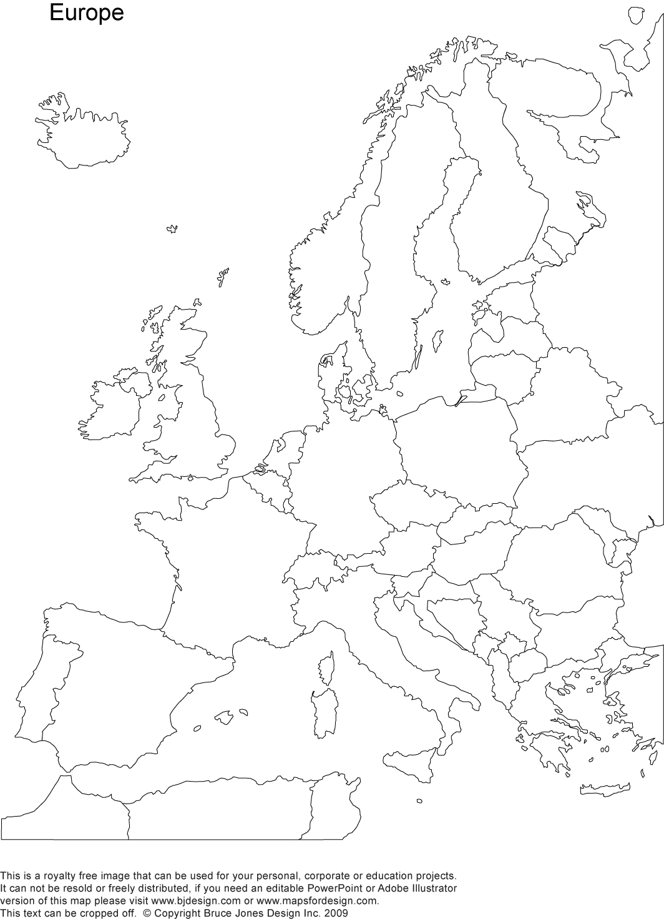

England

Ireland

France

Germany

Netherlands

Belgium

Luxembourg

Switzerland

Liechtenstein

Austria

Norway

Finland

Sweden

Iceland

Denmark

Portugal

Spain

Andorra

Italy

San Marino

Vatican City

Monaco

Malta

Greece

Poland

Czech Republic

Bosnia & Herzegovina

Slovakia

Slovenia

Croatia

Bulgaria

Macedonia

Albania

Montenegro

Hungary

Serbia

Moldova

Label and color the countries of Europe. Label the following water ways, Atlantic Ocean, Mediterranean Sea, Baltic Sea, and English Channel.