Congressional Committees Worksheet
Directions: Using the chart below, choose the correct committee the Bill will originate in for Qs 1-4. For Qs 5-10, please use pages 322-333 in your text.

Example: H.R. 6573: Helping Farmers through Drought Act = Agriculture committee

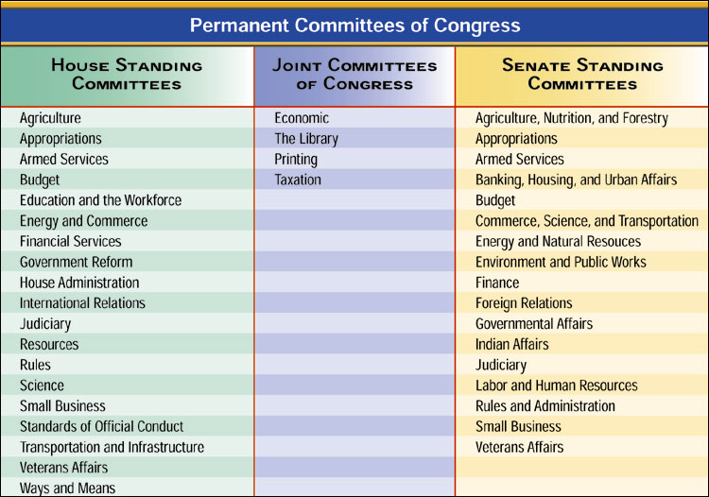

Bill S. 3588: Great Lakes Ecosystem Protection Act of 2012

Bill H.R. 6568: Back to Work Blueprint Act

Bill H.R. 6574: Service-member Mental Health Review Act

S. 3577: Foreign Prison Conditions Improvement Act of 2012

What type of committee would create bills related to a recent terrorist attack in the United States?

What type of committee has members from both the House and Senate?

What type of committee would discuss two different versions of the same bill?

What type of committee would always be in existence?

How are committee chairmen chosen?

Describe the “seniority rule.”

