Name:_______________________

Label and color the countries of Central America, South America, and the Caribbean. Be sure to include the following bodies of water, Pacific Ocean, Atlantic Ocean, Gulf of Mexico, Caribbean Sea, and Amazon River.

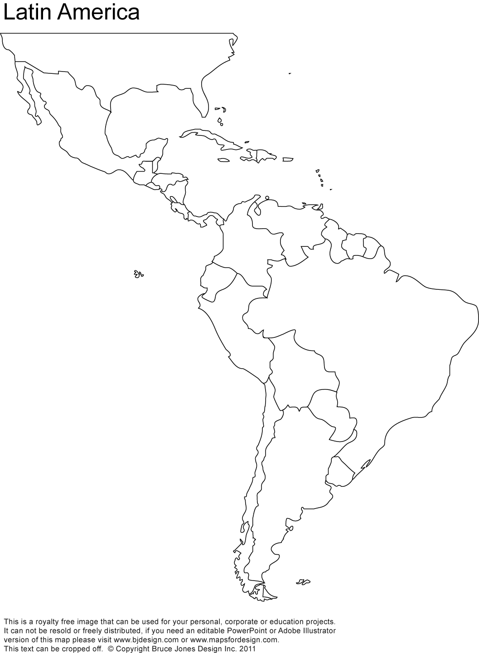

Mexico

Belize

Guatemala

Honduras

El Salvador

Nicaragua

Costa Rica

Panama

Cuba

Jamaica

Haiti

Dominican Republic

Puerto Rico

Lesser Antilles

Columbia

Venezuela

Ecuador

Guyana

Suriname

French Guiana

Brazil

Peru

Bolivia

Chile

Paraguay

Uruguay

Argentina