1. Define the following terms:

**Bill:**

**A proposed piece of legislation in either the House of Representatives or the Senate**

**Committee of the Whole:**

**The entire House of Representatives or Senate**

**Quorum:**

**The minimum number of members necessary to conduct business in one of the houses of Congress**

**Veto:**

**The presidential power to unilaterally decline a bill passed by Congress; can be overridden by a 2/3 vote in both the House and Senate**

**Pocket Veto:**

**When the President takes no action on a bill sent within 10 days of the session of Congress ends, effectively Vetoing it.**

**E**

2. **Complete the following graphic on the right with the letters below (pg. 345):**

**D**

A. The Bill is sent to an appropriate Standing Committee of either the House or the Senate. At this point it can be killed by the committee or sent to the whole House/Senate.

**H**

B. The Bill becomes a law with either a presidential signature or inaction for 10 days while Congress is in session.

**F**

C. The Bill does not become law either by presidential veto or by inaction for 10 days while Congress is not in session.

**G**

**B**

D. The Bill is voted on for the first time in either the House or the Senate.

E. The Bill is sent to the floor of either the House or the Senate for debate by the entire body.

F. The Bill goes to a Conference Committee to settle any differences between the House and Senate versions.

**C**

G. The Bill is voted on again by the entire Congress and if approved is sent to the president.

H. If the president vetoes the bill it is sent back to Congress and can be overridden with a 2/3 majority vote to become law.

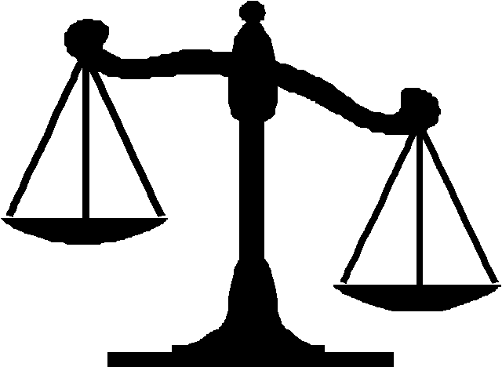

Becomes Law



Does not become Law

House

Senate

**A**

Introduction of Bill