Group Members:
*
*
*
American Time Machine Travel Product

You and your group will be in charge of putting together a sales pitch for a time travel vacation! You will select one decade (10 total years) and put together a vacation to sell to a historical traveler. Each group member will be graded on the overall work of the group and the finished product completed and turned in on time. Please be sure to be familiar with the rubric to ensure that you earn the maximum number of points possible. Below are the requirements for the project

*Poster- Your group should put together a poster advertising your decade and the exciting things that people can see and do during your decade. It should have the decade they are traveling to, 3 places they will visit on their trip, three events they will see. Each of those should have a picture associated with it.

*Road Map- You should have a map completed with points marked on where you have 5 total locations that people will visit. Each point should have an exact date and description (3 sentences) of the event.

*VIP List- Compile a list of 5 total people that your travelers should meet. Each person should have a 3 sentence description explaining what their significance is and where they will most likely be found.

*3 postcards (Done on notecards) from the 3 most relevant American places/events. These can be repeated from the Road map but must come with a personalized letter to someone “back home”.

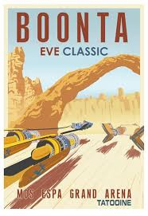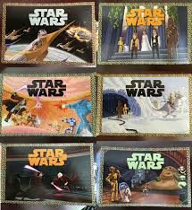

RUBRIC

 | 0-1 | 2-3 | 4-5
Presentation and Historical Accuracy | Students do not provide a professional presentation of materials that have many historical inaccuracies. | Students provide a presentation of materials that have little/no historical inaccuracies. | Students provide a professional presentation of materials that have NO historical inaccuracies.
Poster | Students create a neat and professional poster but has not met MOST of the requirements (Missing 3+ things). Poster has NO COLOR. | Students create a neat and professional poster but has met MOST of the requirements (Missing 1-2 things). Poster has COLOR. | Students create a neat and professional poster that has a slogan and the 3 places that a traveler will see. Poster has COLOR.
Road Map | Students fill in a map with less than the 5 total events that travelers will explore during their trip to the chosen decade. Most descriptions of the events DO NOT meet the sentence minimum (3+) | Students fill in a map with the 5 total events that travelers will explore during their trip to the chosen decade. Most descriptions of the events meet the sentence minimum (4). | Students fill in a map with the 5 total events that travelers will explore during their trip to the chosen decade. ALL descriptions of events meet the sentence minimum.
People to Meet | Students do NOT complete the “VIP” list. Students complete the full 3 sentences for less than 5 “VIP”s including a location to best find them (0-2). | Students complete most of the “VIP” list. Students complete the full 3 sentences for most of the 5 “VIP”s including a location to best find them (3-4). | Students complete the “VIP” list. Students complete the full 3 sentences for each of the 5 “VIP”s including a location to best find them.
Postcards | Students DO NOT create 3 postcards complete with COLORED photo on front and a 3 sentence letter “home” about the place/event they visited (Missing 2+). | Students create most of the 3 postcards complete with COLORED photo on front and a 3 sentence letter “home” about the place/event they visited (Missing 1). | Students create 3 postcards complete with COLORED photo on front and a 3 sentence letter “home” about the place/event they visited.

