Name:________________________

Morocco

Western Sahara

Mauritania

Mali

Nigeria

Benin

Togo

Burkina

Ghana

Ivory Coast

Liberia

Sierra Leone

Guinea

Gambia

Senegal

Guinea Bissau

Label and color the countries of Africa and their capitals. Label the following water ways: Nile River, Atlantic Ocean, Indian Ocean, Mediterranean Sea, and Red Sea.

[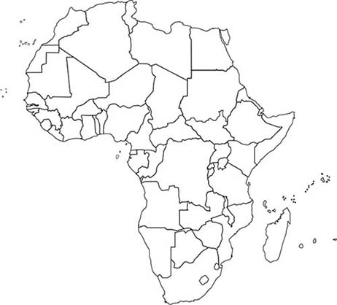](http://www.google.com/url?sa=i&rct=j&q=&esrc=s&source=images&cd=&cad=rja&uact=8&ved=0ahUKEwjD36zQ6e3WAhUo7IMKHRLhAF4QjRwIBw&url=http://www.worldatlas.com/webimage/countrys/af.htm&psig=AOvVaw1w45tpgy9ZJmaKkHgVDk5J&ust=1507991870148563)

Equatorial Guinea

Sao Tome & Principe

Gabon

Congo

Democratic Republic of Congo

Tanzania

Angola

Zambia

Malawi

Mozambique

Zimbabwe

Botswana

Namibia

South Africa

Lesotho

Swaziland

Madagascar

Tunisia

Algeria

Niger

Libya

Egypt

Chad

Sudan

South Sudan

Eritrea

Djibouti

Somalia

Central African Republic

Cameroon

Kenya

Uganda

Rwanda

Burundi