2016 Candidate Research Project
Part One:
- Fill out the Candidate Preference Sheet (first part)
- Complete the Candidate Research Guide.
  - You will be researching the four candidates running for President that’s on the IL ballot.
  - Use the internet to fill out your Research Guides.
    - You can go to the candidate webpages to get all the information you need for each candidate. Or you can also use CNN, New York Times, or any other media to get the information.
  - The Biography part of the guide should include at least 5 basic facts about each candidate and their experience and personal qualities. FYI, facts are not opinions about the candidates!
  - The Top 4 Issues part should have each issue described in a short 1-2 sentence summary for EACH issue!
- After researching, complete the bottom part of the Candidate Preference Sheet.
Part Two:
- Create a campaign poster/newspaper ad/yard sign/flyer/pamphlet for the candidate of your choice.
  - The Poster/Ad/Sign must include the following things for full credit:
    - At least one picture of your candidate (a second picture is suggested for certain projects)
    - The candidate’s full name
    - The party of the candidate (Republican/Democrat) – You can also have the logo of the parties.
    - Mention at least two issues that the candidate cares about
    - A slogan/saying that the represents the candidate and/or their issues
    - The project MUST be creative, colorful and show effort!
    - There must be NO grammatical errors/slang/etc. (this will lead to points deducted)
Examples:
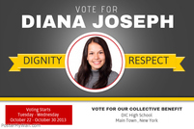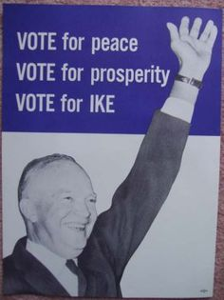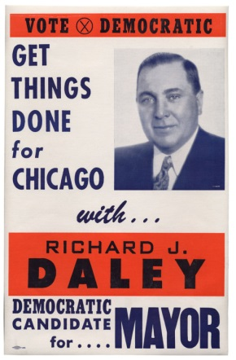

2016 Candidate Preference Sheet
The following exercise will help you to identify a presidential candidate who best reflects your personal interests. You will also be creating a campaign poster/advertisement for your candidate using the information that you collect.
Before researching:
- Looking forward to the 2016 Presidential election, what personal qualities should a candidate possess?

- What type of personal and professional experiences do you look for in a presidential candidate? What issues do you think are most important for a presidential candidate to address in the coming election?

After you fill out the Candidate Research Guide:
- Now, try to match your values and priorities with the individual candidates running for office.
  - Based on your research, which candidate possesses the personal qualities that matter most to you?

  - Based on the personal and professional experiences of the candidates you examined, what candidate do you consider to be best qualified to serve as President?

  - Based on the issues that matter most to you, what candidate comes closest to matching your personal preferences?

- Finally, based on this preliminary research, what candidate are you likely to support in the 2016 election? Why? To which party does he/she belong?

