Al Capone

Early Life
Many New York gangsters in the early 20th Century came from impoverished backgrounds, but this was not the case for the legendary Al Capone. Far from being a poor immigrant from Italy who turned to crime to make a living, Capone was from a respectable, professional family. His father, Gabriele, was one of thousands of Italians who arrived in New York in 1894. He was 30 years old, educated and from Naples, where he had earned a living as a barber. His wife Teresa was pregnant and already bringing up two sons: 2-year-old son Vincenzo and infant son Raffaele. The family moved to a poor Brooklyn tenement where Alphonse Capone was born on January 17, 1899.
But it was Capone's schooling, both inadequate and brutal at a Catholic institution beset with violence that marred the impressionable young man. Despite having been a promising student, he was expelled at the age of 14 for hitting a female teacher, and never went back.
It was then that Capone met the gangster Johnny Torrio which would prove the greatest influence on the would-be gangland boss. Torrio taught Capone the importance of maintaining a respectable front, while running a racketeering business. The slightly built Torrio represented a new dawn in criminal enterprise, transforming a violently crude culture into a corporate empire. Capone joined Johnny Torrio's James Street Boys gang, rising eventually to the Five Points Gang. In a youthful scrape in a brothel-saloon, a young hoodlum slashed Capone with a knife or razor across his left cheek, prompting the later nickname "Scarface."
Torrio moved from New York to Chicago in 1909 to help run the giant brothel business there and, in 1920, sent for Capone. It was rumored that Capone or Frankie Yale killed Big Jim Colosimo, Torrio's boss, that year, making way for Torrio's rule. As Prohibition began, new bootlegging operations opened up and drew in immense wealth. In 1925 Torrio retired, and Capone became crime czar of Chicago, running gambling, prostitution, and bootlegging rackets and expanding his territories by the gunning down of rivals and rival gangs. As Capone's reputation grew he still insisted on being unarmed as a mark of his status. But he never went anywhere without at least two bodyguards. He was even sandwiched between bodyguards when traveling by car. He also preferred to travel under cover of night, risking travel by day only when absolutely necessary. With his business acumen, Al became Torrio's partner and took over as manager of the Four Deuces—Torrio's headquarters in Chicago's Levee area. The Four Deuces served as a speakeasy, gambling joint and whorehouse under one roof.

The Crimes
A crackdown on racketeering in Chicago meant that Al Capone's first mobster job was to move operations to Cicero. With the assistance of his brothers Frank (Salvatore) and Ralph, Capone infiltrated the government and police departments. Between them they took leading positions within Cicero city government in addition to running brothels, gambling clubs and racetracks.
Capone kidnapped opponents' election workers and threatened voters with violence. He eventually won office in Cicero but not before his brother Frank had been killed in a shoot out with Chicago's police force.
Capone had prided himself on keeping his temper under wraps but when friend and fellow hood Jack Guzik was assaulted by a small time thug, Capone tracked the assailant down and shot him dead in a bar. Due to lack of witnesses, Capone got away with the murder, but the publicity surrounding the case gave him a notoriety that he had never had before.
After the attempted assassination of Capone's friend and mentor Johnny Torrio the frail man left his legacy of nightclubs, whorehouses, gambling dens, breweries and speakeasies to Capone. Capone's new found status saw him moving his headquarters to the luxurious Metropole Hotel as part of his personal crusade to become more visible and court celebrity. This included fraternizing with the press and being seen at places like the opera. Capone was different from many gangsters who avoided publicity. Always smartly dressed, he set out to be viewed as a respectable businessman and pillar of the community.
Capone's next mission involved bootleg whiskey. With the help of his old friend Frankie Yale in New York, Al set out to smuggle huge quantities into Chicago. The events would lead to what became known as The Adonis Club Massacre where Capone had Yale's enemies brutally attacked during a Christmas party.
Meanwhile, internal infighting between rival gangsters escalated into street violence and frequent hijackings of Capone's whiskey transports became a big problem. Another thorn in the side for Capone was Frank Yale. Once a powerful associate, he was now seen as the main instigator of disruptions to Capone's whisky business. One Sunday afternoon, Yale met his end with the first use of a "Tommy gun" against him.
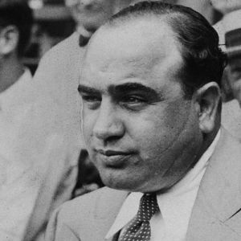

John Dillinger

Background
John Herbert Dillinger was born on June 22, 1903, in Indianapolis, Indiana. As a child, he went by "Johnnie." As an adult, he was known as "Jackrabbit" for his graceful moves and quick getaways from the police. And as a public figure, he was declared the United States' first "Public Enemy No. 1." His exploits during the Great Depression made him a headline news celebrity as well as one of the most feared gangsters of the 20th century. As a boy, Dillinger committed small time pranks and petty theft with his neighborhood gang, the Dirty Dozen. Many of his neighbors would later say he was a generally pleasant kid who didn't seem to get into any more mischief than his peers. But there were also accounts of juvenile delinquency and malicious behavior as a teen. To a degree, both of these perceptions can be seen as correct and were evident in his adult life. Like any celebrity, accounts describing his early life were overshadowed by his later exploits and many of the circulating stories on Dillinger have become that of legend.
Dillinger's mother, Molly, died of a stroke when he was only 3 years old. His sister, Audrey, who was significantly older, raised him until her own marriage a year later, with John Sr. remarrying in 1912. Dillinger quit school at age 16, not due to any trouble, but because he was bored and wanted to make money on his own. He was said to have a talent for working with his hands and was a good employee at an Indianapolis machine shop. In 1920, hoping a change of venue would provide a more wholesome influence on his son, John Sr. sold his grocery store and property to retire to a farm in Mooresville, Indiana. Ever defiant, John Jr. kept his job at the Indianapolis machine shop and made the commute there via his motorcycle.

Early Crimes and Conviction
Having been involved in illicit nighttime activity during his work trips, matters reached a head on July 21, 1923, when the young Dillinger stole a sedan outside of a church, perhaps reacting to a failed romantic relationship. He was later found roaming aimlessly through Indianapolis streets by two police officers, who, after questioning Dillinger and becoming suspicious of his vague explanations, placed him under arrest. Dillinger managed to slip loose from the officers, however, and ran. Knowing that he couldn't go back home, he joined the United States Navy the next day.
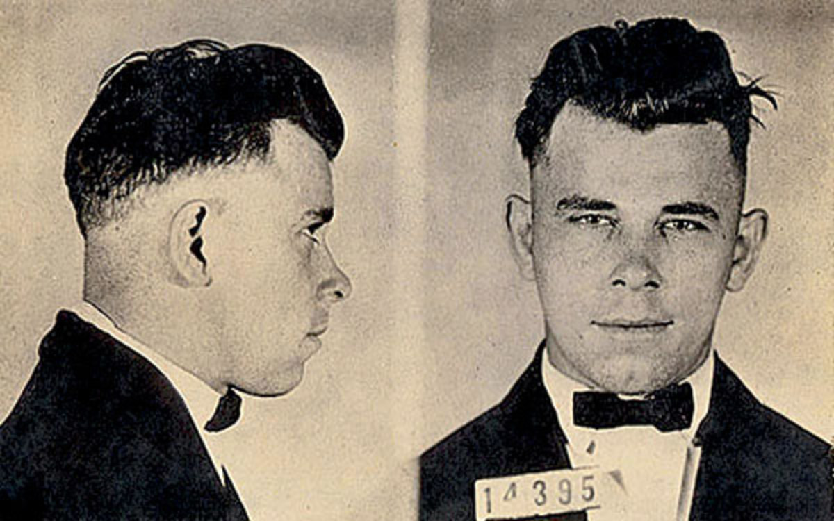
While Dillinger made it through basic training, he quickly realized that the regimented life of military service was not for him. While assigned to the U.S.S. Utah—the same U.S.S. Utah that was sunk at Pearl Harbor in 1941—he jumped ship, ending his five-month military career. He was eventually dishonorably discharged. Upon his return to Mooresville in April 1924, Dillinger met and married teenager Beryl Ethel Hovious in nearby Martinsville and attempted to settle down. With no job or income, the newlyweds stayed both at the Dillinger farm house and the home of Hovious's parents. Dillinger eventually got a job in an upholstery shop.
During the summer of 1924, Dillinger played shortstop on the Martinsville baseball team, where he met and befriended Edgar Singleton. He told Dillinger about a local grocer who would be carrying his daily receipts on his way from work to the barbershop. The plan was that Dillinger could easily rob the elderly grocer for the cash he would be carrying while Singleton waited in a getaway car down the street.
Dillinger was allegedly armed with a .32 caliber pistol and a large bolt wrapped in a handkerchief, with some conflicting reports on whether he or Singleton initiated the attack. Dillinger is said to have come up behind the grocer and clubbed him with the bolt, but the grocer turned and grabbed his attacker and the gun, forcing it to discharge. Believing that he had shot the grocer, Dillinger took off running down the street toward Singleton's getaway car. Singleton wasn't there, however, and Dillinger was soon caught by police.
The local prosecutor convinced Dillinger's father that if his son pleaded guilty to the armed robbery charges, the court would be lenient. That was the extent of his legal assistance, however. Dillinger appeared in court without a lawyer and without his father, and the court threw the book at him: He was sentenced to 10 to 20 years in prison, even though it was his first conviction. Singleton, who had a prison record, was also caught, but would serve less than two years of his two- to 14-year sentence due to legal representation.

Imprisonment
Dillinger was imprisoned at the Indiana State Reformatory in Pendleton, playing on the institution's baseball team and doing seamster work. Dillinger's remarkable skill with his hands came into play just as it had during his time at the machine shop. He frequently completed twice his quota in the prison factory and secretly helped fill other men's quotas. As a result, he gained an array of friends and allies, including Harry Pierpont and Homer Van Meter, two men who would eventually join Dillinger in his life of crime.
Dillinger's wife and family initially visited him frequently. He often penned correspondences to Beryl full of romantic sentiment, with letters like: "Dearest, we will be so happy when I can come home to you and chase your sorrows away ... For sweetheart, I love you so all I want is to just be with you and make you happy ..." But Beryl was not doing well with the separation. She officially divorced Dillinger on June 20, 1929, two days before his birthday. He was distraught, later admitting that the split had left him crestfallen.
That same year Dillinger was denied parole, becoming consumed by bitterness. In a letter he later wrote to his father in October 1933, after several robberies, he confided, "I know I have been a big disappointment to you but I guess I did too much time, for where I went in a carefree boy, I came out bitter toward everything in general ... if I had gotten off more leniently when I made my first mistake this would never have happened." It was during this time that John Dillinger learned the ropes of crime from seasoned bank robbers. In addition to reconnecting with Pierpont and Van Meter, he became friends with Walter Dietrich, who had worked with the notorious Herman Lamm. Previously part of the German military, Lamm had moved to America and was known for planning his bank robberies with a high degree of precision and strategic thought. Dietrich had studied the man's method well and instructed others on how to investigate the layout of a bank and surrounding establishments.

Jailbreaks
Pierpont and Van Meter had longer sentences than John Dillinger, but they weren't planning on serving their full terms, and had already begun planning bank heists for when they were out. Upon leaving prison, they would bribe a few key guards, get a few guns and grab a place to lay low for awhile. But they would need money to finance their jail break. Knowing that Dillinger would be freed the soonest, Pierpont and his colleagues brought him in on their scheme.
In May 1933, the plan got an unexpected boost. Dillinger, who by this time had been in the state pen for almost four years, was notified by his family that his stepmother was near death. He was granted parole, but she died shortly before his return home. Seizing the moment, Dillinger joined a few of Pierpont's men and began a string of robberies. With the aid of two female accomplices, Pearl Elliott and Mary Kinder, Dillinger put the escape plan in motion. He arranged for several guns to be placed in a box of thread and smuggled the package into the shirt factory. The prison break was set for late September.
Having some time on his hands, Dillinger decided to visit a lady friend he'd met earlier that year, Mary Longnaker, in Dayton, Ohio. Unfortunately for them, the police were following him as he gathered funds for the prison break. After receiving a tip from a landlady, they stormed into Longnaker's room and arrested Dillinger. He was sent to Allen County Jail in Lima, Ohio. In the meantime, Pierpont and his men escaped from Indiana State and made their way to a hideout in Hamilton, Ohio.
Dillinger was incarcerated under the care of Sheriff Jess Sarber and his wife, who lived at the Lima facility. The jail was about 100 miles away from Pierpont's hideout, and he soon realized that with some cash and a few guns, he would be able to spring Dillinger. Pierpont and two other men knocked over a local bank and later, armed with pistols, the three men approached the jail house just as Sheriff Sarber and his wife were finishing dinner. Pierpont knocked on the door and announced that they were officials from the state penitentiary and needed to see Dillinger. When Sarber asked for their credentials, they showed him their guns. When Sarber reached for his weapon, Pierpont panicked and shot him, later clubbing the downed officer as well. Mrs. Sarber then gave the men the jail keys and they sprang Dillinger. Sarber died a few hours later—making all members of the gang accessories to murder. Once John Dillinger was free, the gang headed to Chicago to put together one of the most organized and deadly bank robbing gangs in the country. To pull many of the big jobs they had planned, Pierpont and Dillinger knew they needed heavy fire power, ammunition and bullet-proof vests. To get the equipment, they headed to the police arsenal in Peru, Indiana. After casing the joint, Pierpont and Dillinger entered the arsenal, overpowered personnel and stole a variety of weapons.

“Babyface” Nelson

Early Life and Crimes
Notorious bank robber and killer Baby Face Nelson was born Lester Joseph Gillis in Chicago, Illinois, on December 6, 1908. According to some reports, both of his parents were immigrants from Belgium. The New York Times listed his father's occupation as tanner. During his school years, Nelson was known to have a short temper and often got into fights with his classmates.
By the age of 13, Nelson had begun his life of crime. He was caught stealing in 1922 and sentenced to the St. Charles School for Boys. Over the next few years, he was in and out of juvenile facilities. Nelson eventually earned the nickname "Baby Face" for his youthful appearance by his fellow street thugs. He was only five feet four inches tall and weighed roughly 133 pounds.
In 1928, Nelson married Helen Wawzynak. She called herself Helen Gillis, even after her husband had taken on the last name of Nelson. Helen was only 16 years old at the time. The couple soon had a son and a daughter together.

Notorious Bank Robber
Nelson graduated to adult prison in 1931 after robbing a bank in Chicago. Sentenced to a year in jail, he escaped from custody while being transported to be tried on another bank robbery charge in February 1932. Nelson eventually wound up in Sausalito, California where he met John Paul Chase. The pair engaged in numerous criminal activities over the next few years.
Nelson joined up legendary criminal John Dillinger in 1934, shortly after Dillinger's original gang dissolved. Nelson was almost caught that April while he was hiding out with the Dillinger gang in northern Wisconsin. But he shot his way out of the situation, killing an FBI agent in the process. He was with Dillinger and Homer Van Meter during the June robbery of the Merchants National Bank in South Bend, Indiana. A police officer was killed by the gang during the crime.
Nelson headed to California with his wife, Helen, and John Paul Chase for a time. He managed to evade capture for several months, but the FBI finally caught up with him in November 27, 1934. Nelson was driving in a stolen car with his wife and Chase near Barrington, Illinois, when they were spotted by FBI agents. For a time, Nelson tried to drive away and the agents gave chase. He then stopped the car to shoot at the agents. A brief gun battle ensued, which left FBI agent Herman E. Hollis dead. A second agent, Samuel P. Cowley, died several hours later in an Elgin hospital.

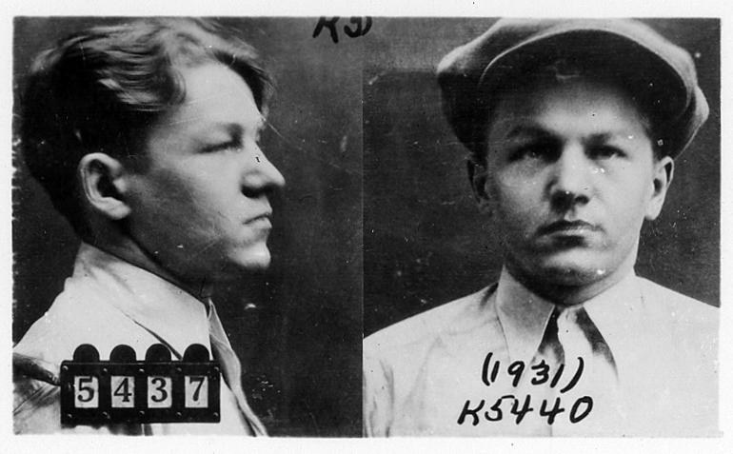

Dean O’Banion
Early life

O’Banion was born to Irish Catholic parents in the small town of Maroa in Central Illinois. In 1901, after his mother’s death, he moved to Chicago with his father and one of his brothers (a second brother, Frank, remained in Maroa). The family settled in Kilgubbin, a neighborhood known as "Little Hell." The heavily Irish area on the North Side of Chicago was notorious for its crime.

"Deanie," as he was known, sang in the church choir at Chicago’s Holy Name Cathedral as a youngster, but he was a petty criminal from an early age. Because of a short left leg, O’Banion was often called "Gimpy," but rarely to his face. The shorter leg is believed to be the result of a childhood streetcar accident, but there are no official records that confirm this.

O’Banion, along with his friends Earl "Hymie" Weiss and George "Bugs" Moran, joined the Market Street Gang, which specialized in theft and robbery for the city’s thriving black market. The boys later became "sluggers," thugs hired by a newspaper to beat newsstand owners who did not sell their paper. The Market Street Gang started out working for the Chicago Tribune, but later switched to the rival Herald Examiner due to a more attractive offer from newspaper boss Moses Annenberg. Through Annenberg, the gang allegedly met safecracker Charles "The Ox" Reiser, who taught them his trade. The gang also met the political bosses of the 42nd and 43rd wards through Annenberg, and they were later hired to use violence to help steer the outcome of elections.

O’Banion was arrested twice in 1909. Once for safecracking and then for assault. These were the only times he spent in jail.

O’Banion worked briefly as a waiter at McGovern’s Liberty Inn, where he would allegedly entertain patrons with his tenor voice while his pals were picking pockets in the coatroom. O’Banion also drugged patrons’ drinks, known as "slipping a Mickey Finn." When the drunk and confused patrons left the club, O’Banion and his pals would rob them.

Life as a bootlegger

With the advent of Prohibition in 1920, O’Banion was one of the first to recognize the potential in bootlegging, and he worked with beer suppliers in Canada, and also struck deals with whiskey and gin distributors. O’Banion is credited with conducting Chicago’s first liquor hijacking, which took place on Dec. 19, 1921.

During another incident, O’Banion and his men stole more than $100,000 worth of Canadian whiskey from the railroad yards, while in yet another event, O’Banion broke into the Sibly Distillery and stole 1,750 barrels of bonded whiskey. O’Banion and his associates, known as the North Side Gang, eliminated all competition and took control of the city’s North Side and the Gold Coast, a wealthy area of Chicago on the northern lakefront. At the height of his power, O’Banion was supposedly making about $1 million a year (in 1920s dollars) on booze alone. In 1921, O’Banion married Viola Kaniff and bought an interest in William Schofield’s River North Flower Shop, near the corner of West Chicago Avenue and North State Street. The investment served a duel purpose: He needed a legitimate front for his criminal operations, and the rooms above the shop were used as the headquarters for the North Side Gang. There was a side benefit to owning the shop, however. It allowed O’Banion to indulge his lifelong love of flowers. He was known as an excellent arranger, and Schofield’s quickly became the florist of choice for mob funerals. The shop was directly across the street from Holy Name Cathedral, and he and Weiss attended mass almost daily.
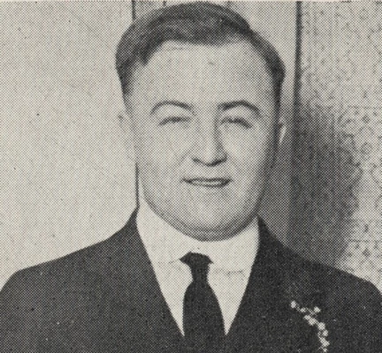

George “Bugs” Moran

Early life
Moran was born to French immigrants Jules and Marie Diana Gobeil Cuninin Minnesota and attended Creighton School. His father was a strict man who often fell out with him but his deeply religious mother was always on his side. It is while at Creighton that Moran ventured into crime by joining local juvenile gangs that were known for muggings, burglary and petty theft. His first encounter with the authorities was when he was caught in a burglary incident at a local store. He was sent to the juvenile correctional facility where he went 3 more times for similar crimes just before 21.
Instead of changing for better, he became a hardcore criminal and escaped to Chicago where he was involved in more robberies, horse stealing rackets and even the death of a police officer. By this time, he was a feared gangster in Chicago together with his new accomplices, Charles “the Ox” Reise, Hymie Weiss, Dean O’Banion and Vincent Drucci.
Just like you’d expect from a mobster, he married twice. His first wife Evelyn Herrell Moran left him because of his criminal lifestyle. He later married Lucille Logan Bilezikdijan Moran with whom they had a son called John George Moran.

Taking Advantage of Prohibition
It is after the enactment of prohibition that Moran and his gang saw a great potential in bootlegging. Smuggling, distributing and selling alcohol was much more viable than robberies. Of course they would sell their alcohol as a scarce commodity and at very high prices. It wasn’t long before they knew the South Side Gang was in business too. Immediately, squabbles begun but they managed to settle them amicably as they were also being targeted by the authorities so laying low was important for both gangs. At that time, the Chicago Outfit was headed by Johnny Torrio, a humble guy who loved peace but sooner than later, he was replaced by the aggressive Alphonse Gabriel aka “Al” Capone who was driven by the desire to control the trade.

The North and South Gangs Feud
Even though most of the feuds between the gangs were managed amicably, the North Side Gang didn’t take lightly the murder of one of their own, Dean O’Banion. It is alleged that O’Banion was killed in retaliation for setting up one of Torrio’s breweries to the police. Moran didn’t take this lightly and being a gangster, he was ready to declare war on the Chicago Outfit. Moran and Weiss then made an attempt on Torrio’s life and this was a clear statement, the cold war that was there was now a real mafia war. Unfortunately, Weiss was murdered before taking out Torrio. Moran was now the head of the North Side Gang.
Moran Breaks Bad
After the unfortunate demise of Weiss, Moran waged a hard war on Capone. He killed prominent figures of the Chicago Outfit, Capone’s closest friends, ambushed his alcohol supplies and even destroyed his nightclubs and businesses. Capone was now on the receiving end. He then went for the kill and planned an attack on Capone’s inner circle. Capone seemed prepared and fought back resulting to the infamous ”The St. Valentine’s Day Massacre”
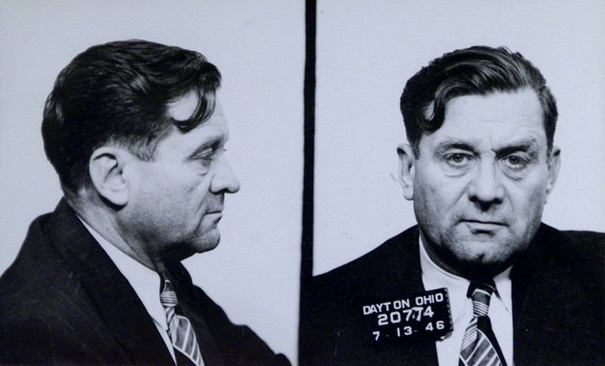
Jack “Machine Gun” McGurn

Early Life
McGurn was born in July 1902 in Licata, Sicily, the eldest son of Tommaso and Giuseppa Gibaldi (née Verderame). Four years later, he and his mother emigrated to join his father in the United States of America, arriving at Ellis Island on November 24, 1906. McGurn grew up in the Brooklyn slums where he went to Public School 46 on Union street between Henry and Hicks streets. McGurn moved to Chicago when he was 14 where he later took up a career in boxing as a teenager and changed his name to "Battling" Jack McGurn because boxers with Irish names got the better bookings. After Tommaso's death while McGurn was still young, his mother remarried to grocer Angelo DeMora, who was later murdered by Black Hand extortionists.

Life of Crime
Legend has it that McGurn was first introduced to Capone after his stepfather, Angelo DeMora, was assassinated by gang extortionists on January 28, 1923, and McGurn had methodically avenged his death by killing the three hitmen responsible. In fact, McGurn was already on the Outfit's payroll by the time of DeMora's death, and had probably come to Capone's attention through his budding career as a prizefighter.
McGurn had part ownership of a speakeasy jazz club, a venue which still exists today, the infamous Green Mill, at 4802 North Broadway, in the middle of the rival "Bugs" Moran gang's territory. In November 1927, manager Danny Cohen gave McGurn the task of "persuading" comedian/singer Joe E. Lewis not to move his act south to the New Rendezvous Café, at North Clark Street and West Diversey Parkway. Lewis refused, and McGurn slit Lewis's throat, cutting off a portion of his tongue and leaving him for dead. Miraculously, Lewis eventually recovered and resumed his career, but his voice never regained its lush sound.

Later Years
In April 1930, when Frank J. Loesch, chairman of the Chicago Crime Commission compiled his "Public Enemies" list of the top 28 people he saw as corrupting Chicago, McGurn's name was fourth on the list, which was published nationwide.
This notoriety caused him to be shunned by the Outfit. So McGurn, who had great hand-eye coordination, attempted a career as a professional golfer. McGurn was a silent partner in Evergreen Golf Course, at 91st Street and Western Avenue, a known mob hangout where McGurn could often be found playing, practicing, giving lessons, or drinking and playing cards in the clubhouse. Dan Lilly was known to have caddied for him once and claimed that he kept a machine gun in his golf bag a all times.
On August 25, 1933, the Western Open golf championship began at Olympia Fields Country Club in the far south suburb of Olympia Fields. A reasonably skilled golfer and flashy dresser, McGurn entered the competition as Vincent Gebhardi (another version of his real name), the professional at public Evergreen Golf Course. In the opening round, McGurn carded a 13-over-par 83 on course No. 4 (today's North Course). The next morning, the name "Gebhardi" on the day's pairing sheet was observed by an alert Chicago Police chief detective, who sent two sergeants to arrest him. "Aware of McGurn's truculent temper," the Chicago Tribune account reported, "the sergeants enlisted the help of Lt. Frank McGillen and five policemen from the Homewood station of the county highway force."
McGurn was playing much better the second day. The group of burly officers accosted McGurn on the seventh green and told him he was under arrest under a warrant issued the day before under the "criminal reputation law". He was accompanied by his wife, the glitzy "Blonde Alibi" Louise Rolfe, who was dressed to the nines. Wearing a tight, thin white dress and sporting a three-carat diamond ring, she approached the policemen and snapped, "Whose brilliant idea was this?" McGurn politely asked to finish his round. Amused, the plainclothesmen agreed and became part of his gallery. But the police presence began to unnerve McGurn and his game suddenly went sour. He came in with a 16-over-par 86 for a 36-hole total of 169, 14 strokes above making the cut.

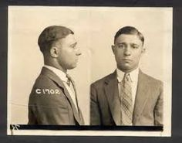
THE CRIMES
On the Bio Sheets Assign each of these crimes to one of the 1920’s Gangsters and provide a rationale why.

- 200 crates of Canadian Whiskey smuggled into Chicago’s Speakeasies all across the Italian South Chicago.
- Lima prison escape in connection to the raid on the Peru Police Armory.
- Battle of Barrington- Shot 3 FBI Agents, stole Jewellery of the Mayor’s wife (Big Bill Thompson)
- Walked with a limp. (“Gimpy”), Irish bootlegger on the Northside of Chicago. Murder of South Side hitman, John Duffy.
- Leader of the northside gang. Coordinated all smuggling and bootlegging. Attempted to kill Al Capone.
- Attack on Joe E. Lewis at the Green Mill Speakeasy.Connection with Saint Valentine’s Day Massacre

